Planning and Managing
Complex Test Resource Logistics
Rex Black; President and Principal Consultant, RBCS, San Antonio, TX
Key Words: Hardware, software, configuration, logistics, test management, development management, project management, configuration management, release management.

Abstract
Subtle but catastrophic bugs, such as those that cause server crashes and database record-lock race conditions, often only reveal themselves during performance, stress, volume, data quality, and reliability testing. Such testing is most effectively performed in test environments—hardware, software, network, and release configurations—that mimic as nearly as possible the field environment, because test results in less-complex settings often do not extrapolate due to the non-linearity of software. In complex settings, such as Web and e-commerce server and database farms, managing these lab configurations can be quite challenging. This paper presents a basic Access database, designed using the Entity-Relationship technique, that will allow the Test Manager to plan, configure, and maintain this test environment through the test project.

Introduction
Testing finds the most critical, customer impacting bugs when performed under conditions that simulate, as closely as possible, the deployed environment. Performance, stress, volume, data quality, and reliability tests often find non-linearities—failures to scale to expected, peak, and sustained loads-that can be unique to the precise configuration tested. Setting up a realistic test environment requires acquiring and configuring production hardware as the first step in equipping the test lab. On projects with complex hardware requirements, getting the test lab properly provisioned and operational can involve planning for, configuring, and maintaining complex hardware configurations, sometimes at a variety of locations. Occasionally these configurations must move or change during the test project. The Test Manager often must manage these logistical challenges to ensure minimum impact to the test schedule.
In addition to tricky hardware asset management, complex and distributed test environments make testing that much harder on the people, too. Sometimes test engineers oversee test tasks that take place in separate locations—even in other countries.
The following paper is based on my experience managing test resources, including complex, international software, hardware, and systems development projects. I will introduce the audience to a database that will allow attendees to plan, track, manage, and report the following:
- Hardware installation, locations, and relocations.
- Current, historical, and planned hardware configurations.
- Hardware interconnections and networking.
- Test locations.
- Test infrastructure.
- Test engineer assignments and locations.
- Human resource deployment.
Starting with an Entity-Relationship database design, I will implement a logistics management database using Access 97. The tables capture the different data elements for each entity. Proceeding on to the relationships, I will demonstrate look-up tables that capture the many-to-many relationships that exist between each object.
With the data defined, I will introduce a number of reports that present different views of the database. Each view has value for different audiences:
- The IS, MIS, or IT manager.
- The project manager.
- The testers.
- The test manager himself.
I will demonstrate the use of the database with a case study based on real projects.

Case Study
In the following paper, I use a case study approach to introduce these charts. The case study is a hypothetical software development project, undertaken at a fictitious company called Software Cafeteria, Inc. to implement a Java-based word processing package code-named SpeedyWriter. This product will have all the usual capabilities of a full-featured word processor, plus network file locking, Web integration, and public-key encryption. Figure 1 illustrates the hardware, network, and operating system environment in which the tests will run.
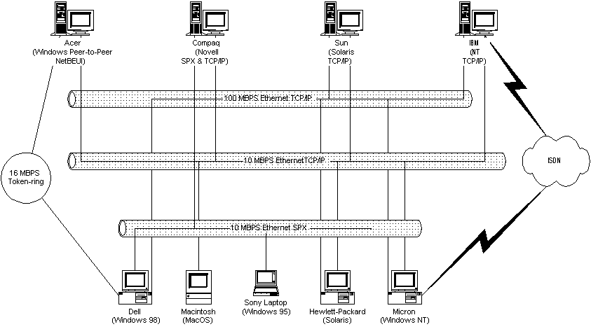
Figure 1: The SpeedyWriter test environment
In addition to hardware, the test project involves four people and two external resources. Mohammed Zaman serves as the test manager, Lin-Tsu Woo is the test engineer on the project, and John Goldstein and Liz Campbell are test technicians. The sales and marketing team provide localization testing in the foreign sales offices, while STC, a (fictitious but not atypical) third-party test lab, provides off-site compatibility testing.
Note that this project is simplified in comparison to an e-commerce Web site like Amazon.com. However, it allows me to illustrate the essentials of the database without getting bogged down in irrelevant details. I have used this database to manage test project logistics involving dozens of servers, hundreds of clients, scores of people, and complex networking infrastructures.

Entities and Relationships
Because this database is complex, it’s useful to begin with a conceptual overview of the elements and how they relate. Figure 2 shows an Entity-Relationship (E-R) diagram for the database. Those of you who have some familiarity with database design or administration probably recognize this format. But if it’s new to you, don’t worry; you don’t have to understand database design to use this tool.
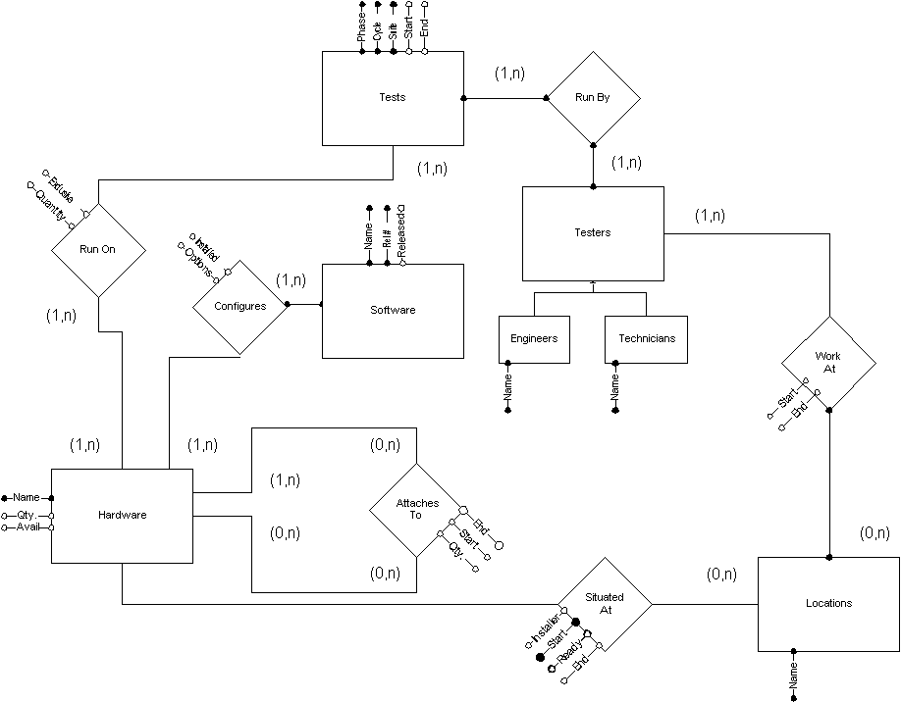
Figure 2: Logistics database Entity-Relationship diagram
The rectangles in Figure 2 represent entities, which are objects of some kind. An entity can be broken down into categories; the Testers entity, for example, breaks down into two categories, Engineer and Technician.
Each entity has a set of properties, represented by labeled lines. One (or more) of these properties, called the key, taken together uniquely identify an individual entity. In Figure 2, lines with solid endpoints indicate key properties, whereas lines with open endpoints indicate non-key properties. For example, Name is a key property of the Hardware entity, while Quantity is a non-key property of this entity.
The diamonds represent relationships between pairs of entities. Relationships can also have properties. (Not all relationships have properties though; relationships are identified by the entities they associate.) There are three kinds of relationships: one-to-one, one-to-many, and many-to-many. In a one-to-one relationship between entities X and Y, any one Y can have a relationship with one and only one X, and vice versa, much like a marriage. A one-to-many relationship between X and Y would allow any one X to have relationships with multiple Ys, but each Y could have a relationship with only one X. In a many-to-many relationship, both X and Y are unrestricted.
In an Entity-Relationship diagram, you can tell what kind of relationship exists by looking at the parenthetical notations on the entity ends of the lines connecting the entity pairs to the relationships. These are referred to as the minimal and maximal cardinalities. For example, (0,1) means either none or one entities participates in this side of the relationship. If the other entity involved in the relationship also has (0,1) cardinalities with this entity, the relationship is one-to-one. The cardinalities (1,n) imply no maximum number of participating entities. If the other entity has (0,n) cardinalities, the relationship is many-to-many.
Let’s look more closely at each entity and relationship in Figure 2. The Tests entity, with five properties, appears at the center top of the chart. The value of the Phase property can be Component, Integration, or System. Cycle is the sequence number of the test cycle in that phase; the Suite property is the name of the suite. (Alternatively, you could use an ID number for the Suite property, although a number is less descriptive.) These first three properties taken together uniquely identify an individual test, as in Integration Test, 2, GUI/Edit Engine. The Start and End properties indicate the scheduled run dates for that suite in that cycle.
Proceeding clockwise around the diagram, you can see that the entities Tests and Testers are linked by the relationship Run By—in other words, tests are run by testers. Testers can be categorized as engineers or technicians; either way, testers are uniquely identified by their names. Because one or more testers run each test, and each tester runs one or more tests, the relationship is many-to-many.
Testers work at locations—that is, the Work At relationship links the Testers and Locations entities. A location can have a description (the Description property) such as an address or a purpose, for clarity. In some cases, locations are temporary, within the time frame of the project, so the relationship includes start and end dates. Testers might work at more than one location during a given period of time. Furthermore, a single location might have 0, 1, or more testers working at it at any given time. Therefore, the relationship is many-to-many.
Let’s return to the top of the diagram and work our way counterclockwise and down. Tests run on one or more items of hardware, each of which in turn runs one or more tests. A test requires a given quantity of the hardware items, usually one but sometime more, and the test’s relationship with the hardware can be either exclusive or nonexclusive, depending on whether the test requires dedicated use of that piece of hardware during its execution. For a hardware item, the properties of interest are Name, Quantity, Available (the date of availability), and Description.
Software configures most hardware items—that is, the particular combination of software items installed on a piece of hardware, and the way in which they are installed, determines the hardware’s functionality. The Software entity has four properties of interest: Name, Rel # (the release number), Released (the release date), and Description. The software configures the hardware on the date on which it is installed with particular options.
In a networked or telecommunications environment, a given piece of hardware attaches to one or more other pieces of hardware. Routers, hubs, and switches attach to many devices at once; modems, keyboards, and mice attach to one computer at a time. Such attachments have start and end dates, and the quantity required is also relevant.
Finally, hardware items are situated at a particular location during certain periods of time. In the Situated At relationship, an installer sets up the hardware, starting on a particular date. The hardware will be ready for test on a date shortly thereafter, and the hardware will end its sojourn at that location at a later date.

Implementing the Logistics Database
To implement the logistics database, I have used Microsoft Access, but you can use any relational database. Begin by creating a table for each entity. Each table should contain a field for each entity property.
Because each relationship is many-to-many, the relationships in the diagram also translate directly into tables. A table for a many-to-many relationship includes the keys from the two related tables, with the combined keys and possibly some relationship properties used as the key for the relationship table. The relationship table also contains fields for each property in the relationship.
I have not provided the design details for each table, but they are not complex. Most of the fields are basic text, integer, or date fields, except for the Exclusive field in the Run On table, which is a yes/no field. Figure 3 shows the tables and their relationships.
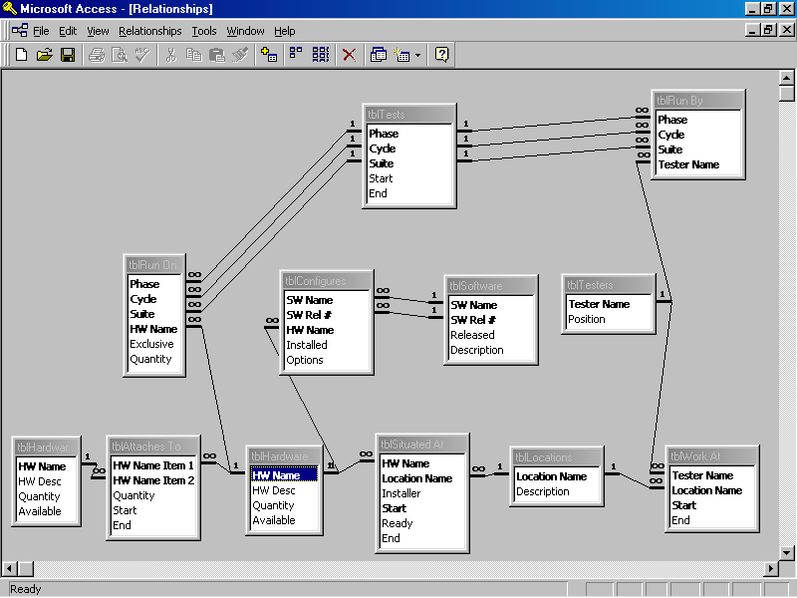Figure 3: Access implementation of logistics database E-R diagram, relationship view

Using the Logistics Database to Budget and Plan
One of most important uses of the logistics database is as a planning tool. The following sections walk through an example of how to use the database, based on a case study of SpeedyWriter test logistics. The example illustrates how you can enter data in the database’s tables and then display it in simple but powerful reports. This database does not support form-based data entry, although you might want to add this and other enhancements if you choose to make the logistics database part of your standard toolkit. To keep the data manageable in this example, I have omitted test development, but you need to allocate hardware and people for test development on most test projects.

The Tests, The Testers, and Test Locations
To begin planning the SpeedyWriter test project, you can start with individual tests and who will run them. Figure 4 shows the table created for the Tests entity, detailing the test suites to be run during the various phases, along with their constituent cycles. A table of testers appears in Figure 5, and the table in Figure 6 represents the Run By relationship, which matches testers to tests. Note that some tests require more than one tester and that some testers run more than one test. Also note that two of the “testers” aren’t people: “STC” is the external test lab and “Sales/Marketing” refers to the internal sales and marketing staff.
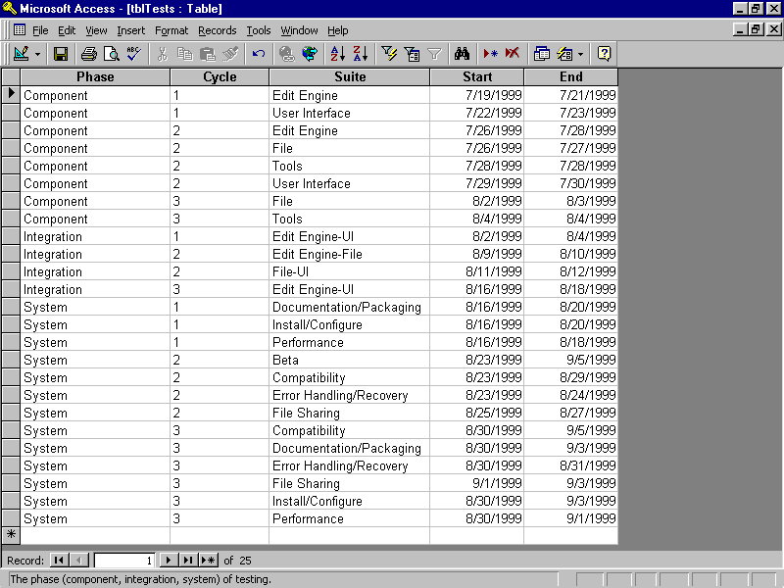
Figure 4: The SpeedyWriter test suites and their scheduled start and end dates
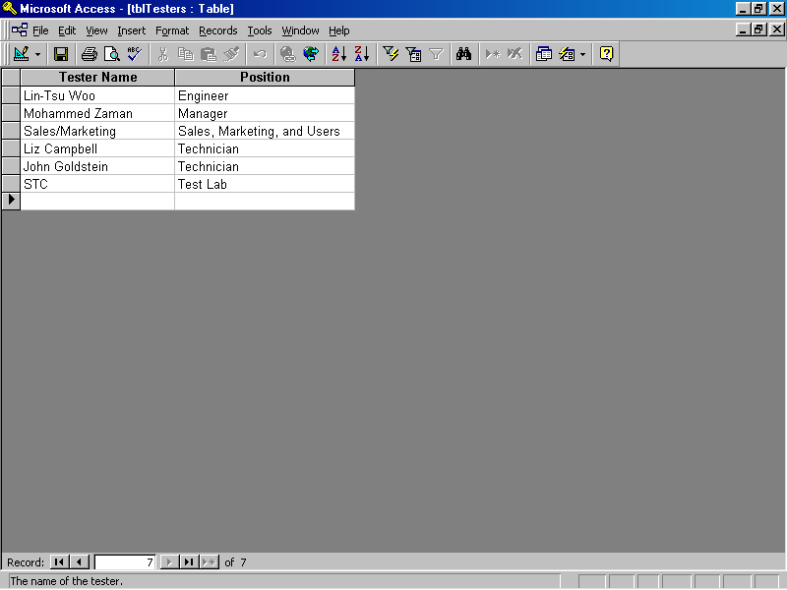
Figure 5: The SpeedyWriter testers
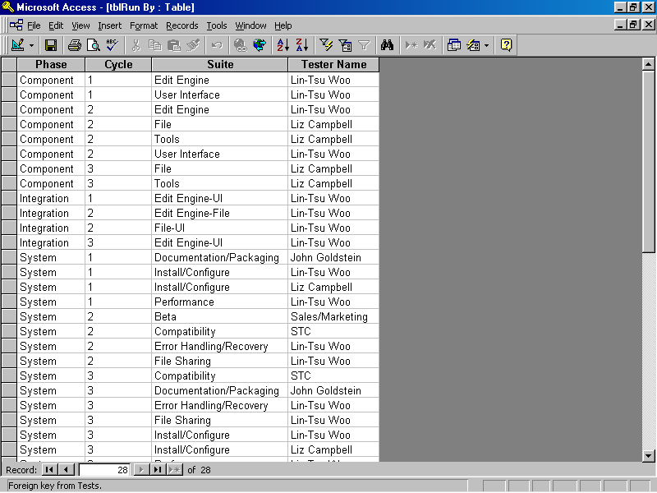
Figure 6: SpeedyWriter test assignments
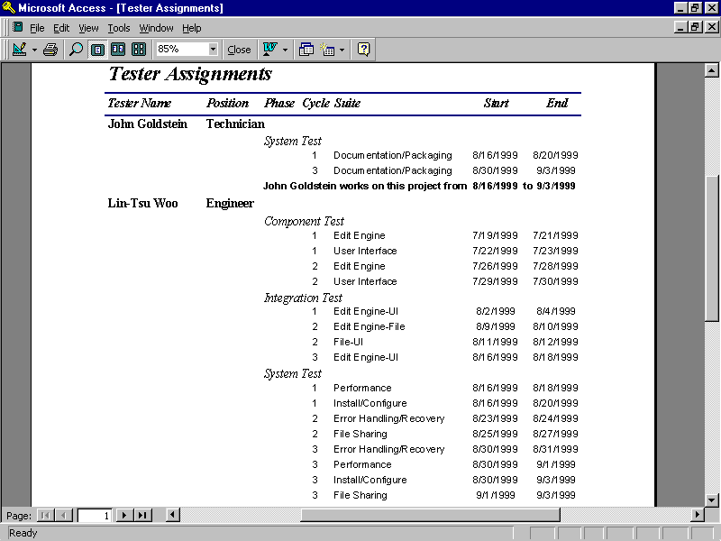
Figure 7: The Test Assignment report
Alone, the three tables shown in Figures 4, 5, and 6 don’t do a good job of telling you who’s doing what when. Why manually cross-reference the three tables when you can create reports based on a query that joins all three? In Figure 7, for example, you’ll find a report titled Tester Assignments that documents which tester performs which tests, and when.
An alternative view of the same information, shown in Figure 8, documents when and by whom each test is run. You might notice that in this Test Schedule report the tests run finish-to-start with no down time in between. This is fine if you have built slack into the duration of each test suite; for example, three days are scheduled for the Edit Engine test suite during the component test phase, even though it is likely to take only two days. But if you use a best-case estimate for each suite and pack the tests as shown here, you will find yourself either slipping the schedule or requiring lots of weekend work from your testers when expectations aren’t met.
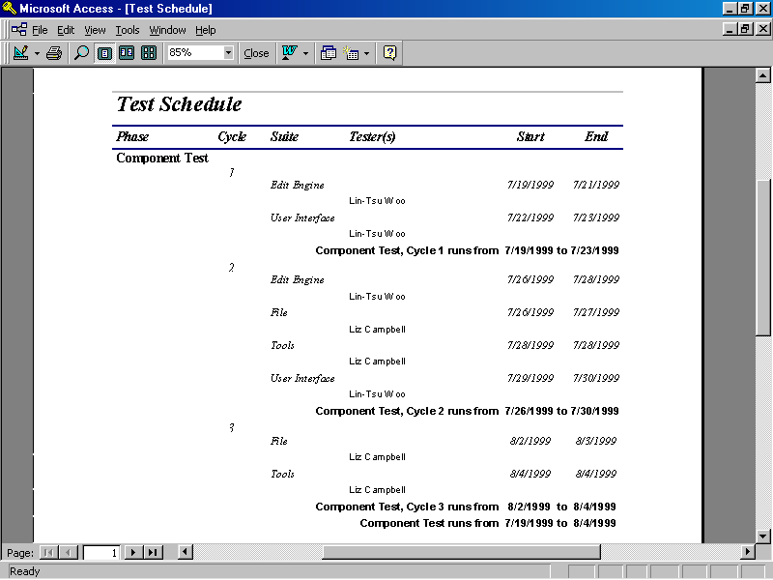
Figure 8: The Test Schedule report
Next you need to address the question of where the test work happens. The table in Figure 9 indicates possible locations for the testers and the hardware. The table in Figure 10 represents the Work At relationship, which matches testers with locations. (Note the use of 1/1/1900 to indicate “as far in the past as is relevant to this project” and 12/31/9999 to indicate “for the duration of this project.” Rest assured that Lin-Tsu, Liz, and Muhammad will not spend 8100 years at Software Cafeteria, although on some late nights it might feel that way.) The real globetrotter of the team, you can see, is John Goldstein, the resident technical writing evaluator. He spends the first week testing at the Engineering office, stays for a week of meetings related to another project, returns to his home office for what he hopes will be a final review of the documentation, and then jets off to the Sales and Marketing office to help with the product launch.
Rather than putting together a report that merely correlates testers and locations—the table is simple enough, after all—you can generate two reports that tie together tests, testers, and locations, as shown in Figures 11 and 12. The first is location-oriented, organized by place; the second is test-oriented, providing the location last. As you can see, these reports can, to a great extent, supersede some of the previous reports.
A certain amount of magic is required in the query, which is shown in Figure 13. The database join by itself does not restrict the testing by location, since it is the date on which the tester performs the test, together with the tester’s location at that time, which determines where the testing happens. Therefore the two date-matching criteria shown in the join are essential to making the query—and the reports that use it—work.
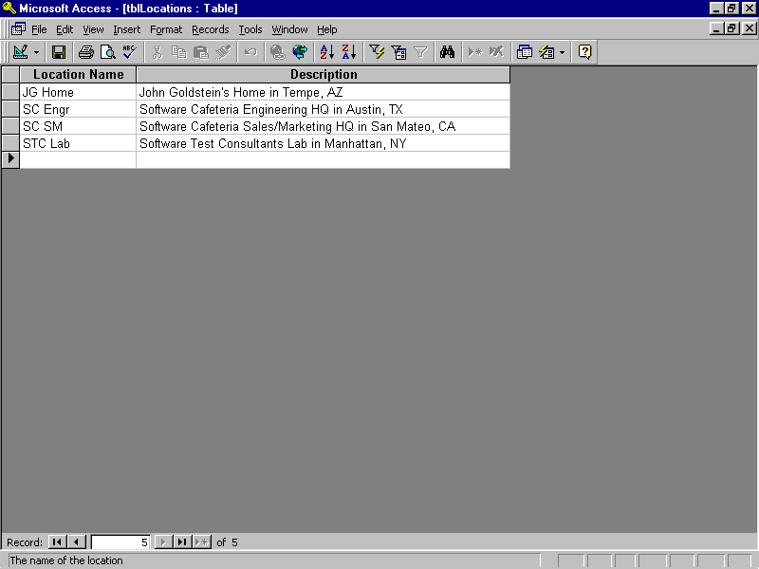
Figure 9: Equipment and test locations
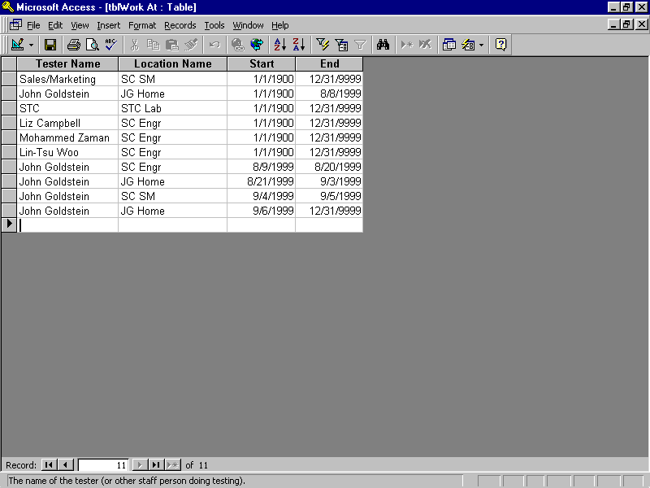
Figure 10: Where people work
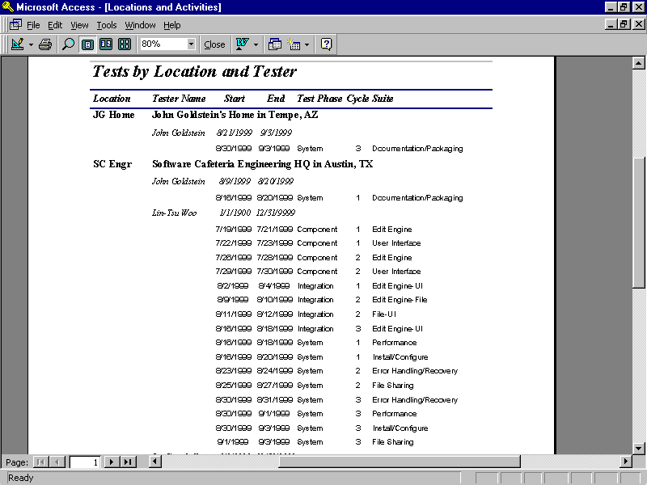
Figure 11: Tests by Location and Tester report
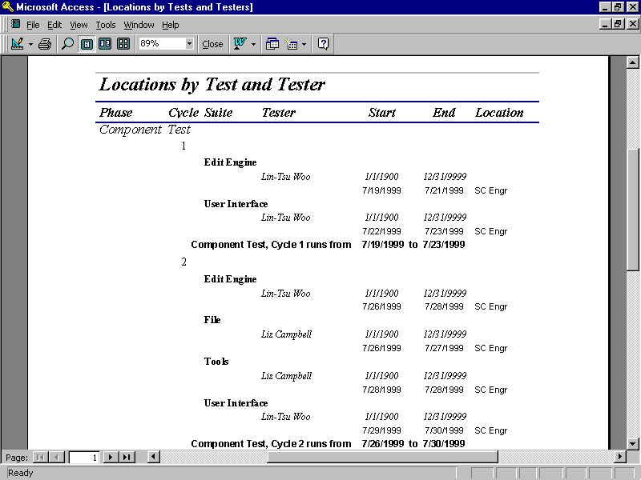
Figure 12: Locations by Test and Tester report
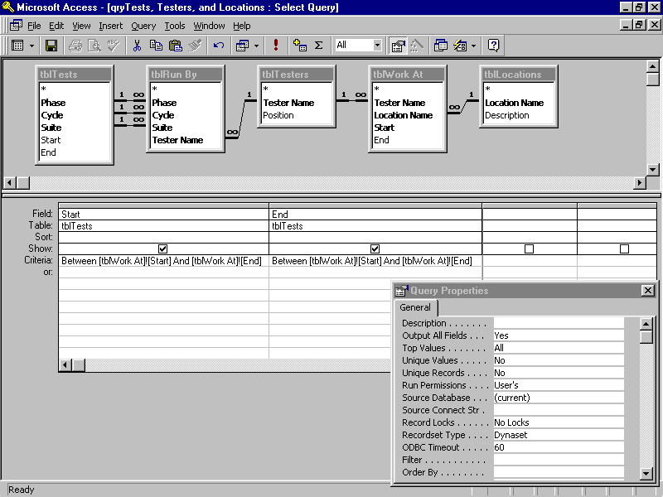
Figure 13: A query to select test locations based on dates

Planning Hardware and Infrastructure
Let’s move on to the issue of managing hardware and infrastructure, starting with hardware. You can use the logistics database to plan for the hardware, software, and infrastructure items you need, to organize how these items will be assigned and shared, and to track various configurations.
For the SpeedyWriter case study, hardware and infrastructure come in three flavors: clients, servers, and networking/telecommunications devices. Let’s assume that you want to cover five operating systems on the client side: Mac OS, Windows 95, Windows 98, Windows NT, and Sun Solaris. As noted earlier, SpeedyWriter testing starts in mid-July and runs through early September. Suppose that three client systems are available in the test lab during this time: a Sony laptop, a Macintosh, and a Dell desktop. By purchasing two other clients—say, a Hewlett-Packard and a Micron—you can cover all five target client platforms. Figure 14 shows the beginnings of your hardware collection for SpeedyWriter testing, including the operating systems run on each platform.
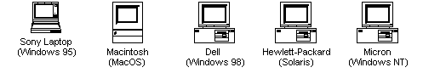
Figure 14: Client SpeedyWriter test platforms
Two questions might occur to you at this point. First, why not simply plan to use the testers’ workstations as test platforms? Sometimes you should do this. In our example, John Goldstein uses his PowerBook to do the documentation and packaging testing. Testers will undoubtedly install SpeedyWriter on their workstations and use these for isolation. Usually, however, you want your test clients to be “clean” configurations. Using an individual’s workstation can create questions about bugs. For example, did the software under test corrupt the registry, or does the problem stem from the old shareware game the user installed six months ago that never would completely uninstall?
Second, could you save money by allocating only two or three systems and using partitioning and multiboot utilities to install and select multiple operating systems on each? Again, this is sometimes a good idea. When testing software, you indeed might want to be able to boot different operating systems on a single platform to determine whether bugs are hardware-related. But don’t plan on saving money by getting too clever with your test hardware allocation. Do you want one bug on a single platform/operating system combination to bring other scheduled testing to a halt because you have a platform shortage? How many wasted hours of a contractor’s or technician’s time will pay for a $2,500 computer? Of course, when you’re talking about $250,000 servers, the story is different, but those servers can frequently support multiple users simultaneously. A client computer running tests is generally exclusively allocated for those tests for the duration of the tests.
Let’s assume that you want to cover four logical network types: Windows 95 peer-to-peer (NetBEUI), Novell (SPX and TCP/IP), Solaris (NFS with TCP/IP), and Windows NT (TCP/IP). Suppose that everything except the Windows 95 peer-to-peer server is already up and running in the building; you can then budget an inexpensive Acer system to serve as the cooperating host. The systems attach, variously, to five different physical network types: 100 Mbps Ethernet TCP/IP, 10 Mbps Ethernet TCP/IP, 10 Mbps Ethernet SPX, 16 Mbps token-ring NetBEUI, and ISDN dial-up networking TCP/IP. (It’s important to include different physical network types because different network connections require different drivers on the client side, which can intersect with application operations—even though they’re not supposed to do so.) For convenient reference, Figure 15 reprises Figure 1, the test lab configuration with these clients, servers, and network types.
Figure 15: The SpeedyWriter test environment
Although you have now defined a test network without much regard to the specific tests you will run on it, this is not a case of putting the cart before the horse. Your test network definition grew out of your coverage goals for the clients, servers, and network types. Having met these goals, you can now distributed the test suites (“shotgun”) across the various client configurations. Notice that by spreading the testing over the clients, you can also cover the servers and networks easily, provided you make sure that tests actually do exercise all the network connections available to the clients.
Your next task is to set up some reports. You can begin by creating tables based on the Hardware entity and the Run On and Attaches To relationships from Figure 2. In much the same way you created reports for the tests and the testers, you can create two reports for tests and hardware, including the attached hardware in this case. Figure 16 shows the Hardware Assignment report, organized by hardware; Figure 17 shows the Test Hardware report, organized by tests. The former is useful for system administrators and for preparing budgets, while the latter helps testers and test managers understand what hardware they will use to run tests (and also helps you spot missing hardware).
You will also need to situate the hardware. In this location table, we show all the hardware located at the Software Cafeteria Engineering headquarters in Austin, Texas. Typically, I use a finer granularity for locations than this example allows, which enables me to track places such as “Second Floor Lab,” “Thermal Chamber,” and so forth. If you want to use this database to manage tight or limited spaces, you should consider this level of detail. In addition, you might want to include footprint areas and overall dimensions for servers and other lab equipment so that you can compare the space taken up by the hardware in a lab to the space available in the lab.
As a final note, let me point out another simplification contained in this section. This example does not account for the hardware that the sales and marketing beta sites will provide, nor does it include the STC lab’s hardware. To use this database to ascertain hardware coverage, you would certainly need that level of detail. However, I usually capture that kind of data in the test tracking spreadsheet.
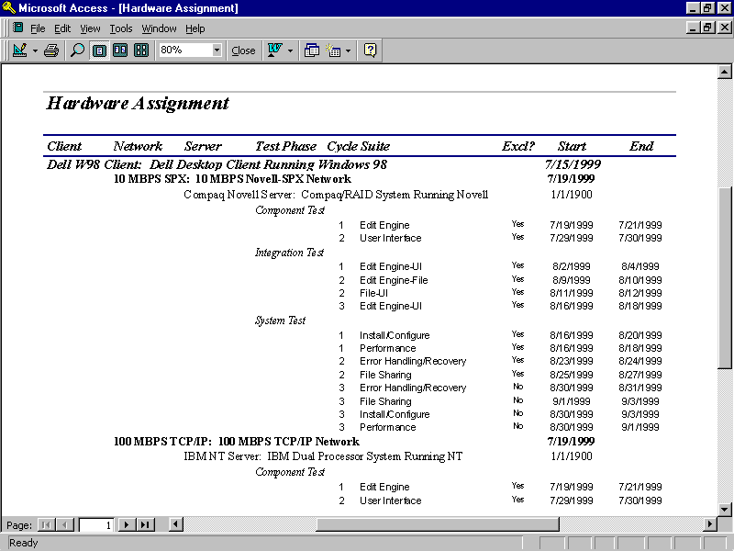
Figure 16: Hardware Assignment (to tests) report
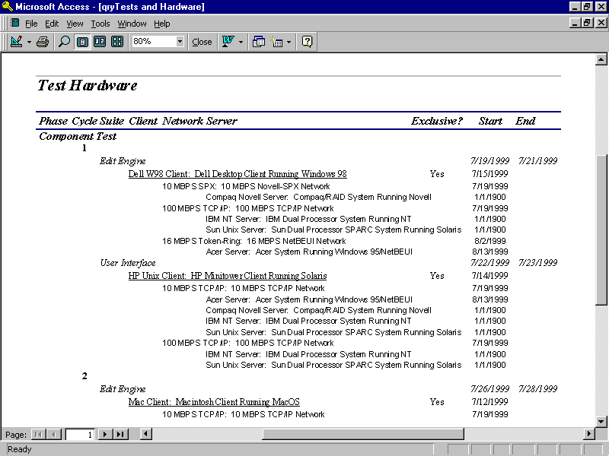
Figure 17: Test Hardware report

Tracking Software Configurations
In general, you can use the logistics database to track all kinds of software configurations on test hardware. You can trace BIOSs, operating system versions, applications, virtual machines and interpreters, compilers, utilities, test tools, test scripts, and other software revisions. To keep our case study simple, though, this section shows only SpeedyWriter software revisions.
Unlike the hardware and human logistics planning discussed in the preceding sections, this section focuses on a dynamic aspect of the database. In this example, software is arriving according to a release schedule but rather unpredictably within a one- or two-day window. Table 1 shows the planned release schedule for each flavor of SpeedyWriter (that is, for each of the five host, or target, client systems: Mac OS, Windows 95, Windows 98, Windows NT, and Solaris), with the associated test phase and cycle. In addition, releases of SpeedyWriter for each host system are planned for the same day.
Revision Identifiers | Release Date | Phase | Cycle
C.1.Mac  C.1.W95  C.1.W98  C.1.WNT  C.1.Sol | 7/19/1999 | Component | 1
C.2.Mac  C.2.W95  C.2.W98  C.2.WNT  C.2.Sol | 7/26/1999 | Component | 2
I.1.Mac  I.1.W95  I.1.W98  I.1.WNT  I.1.Sol | 8/2/1999 | Component  Integration | 3  1
I.2.Mac  I.2.W95  I.2.W98  I.2.WNT  I.2.Sol | 8/9/1999 | Integration | 2
S.1.Mac  S.1.W95  S.1.W98  S.1.WNT  S.1.Sol | 8/16/1999 | Integration  System | 3  1
S.2.Mac  S.2.W95  S.2.W98  S.2.WNT  S.2.Sol | 8/23/1999 | System | 2
S.3.Mac  S.3.W95  S.3.W98  S.3.WNT  S.3.Sol | 8/30/1999 | System | 3
Table 1: Planned releases for target platforms
The plan shown in Table 1 looks good, but it probably won’t survive its first encounter with reality. Good tests will find bugs, which will delay releases. Some bugs hold up the releases to the point that entire revision levels will be skipped for certain cycles. Logistical problems—lack of proper build platforms, compiler glitches, and so forth—will also detain releases. Every now and then releases will come in early. And some releases might be skipped because the previous test cycle did not find any bugs in them.
Let’s take a hindsight view of what actually happens. Figure 18 shows a snapshot of a table based on the Software entity. If you are using the railroad method of spreading test suites across configurations, you can assume that delayed and even skipped releases do not affect the planned execution of tests. Figure 19 shows the Tested Configurations report, which cross-references tests against hardware and the software running on those platforms. (Of course, you could also produce a report that was organized by software and showed the tests run against the software configurations.) Since SpeedyWriter runs on the client side, this report does not show the networks or servers.
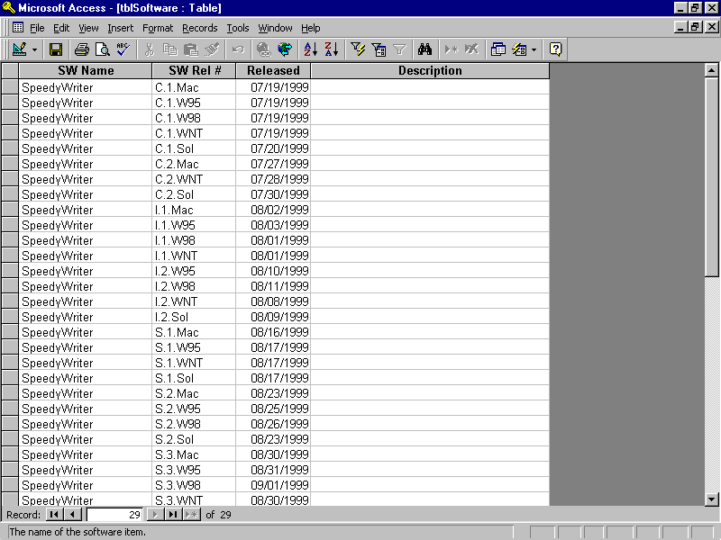
Figure 18: Software release table
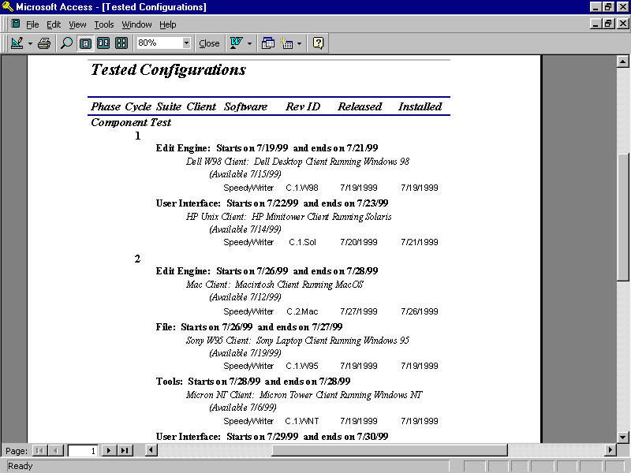
Figure 19: Tested Configurations report

Conclusion
The database presented in this paper provides you with a basic tool for managing complex testing logistics. By managing these logistical issue carefully, you can keep testing focused on finding critical, customer impacting bugs under “near-field” conditions by running realistic simulations of performance, stress, volume, data quality, and reliability. This database will also handle distributed test environments and the human logistics. Finally, you can plan, then track, software releases onto the test environment. This is a critical piece of information for bug tracking and regression testing. A well-prepared Test Manager, using this database, can keep the logistics under control and his eye on the goal of finding as many dangerous bugs as possible.

Presenter Biography
Rex Black has spent sixteen years in the computer industry, with thirteen years in testing and quality assurance. He is the President and Principal Consultant of Rex Black Consulting Services, Inc., an international software and hardware testing and quality assurance consultancy. In this work, he consults on and practices planning, management, and techniques for software and hardware testing projects. His clients include Dell, SunSoft, Hitachi, Netpliance, Motorola, IMG, Renaissance Worldwide, Omnipoint, Pacific Bell, DataRace, Omegabyte, Strategic Forecasting, and Clarion. His work with these clients has taken him to Taiwan, Hong Kong, Japan, the U.K., Canada, Germany, Holland, France, Spain, Switzerland, and Italy, along with locations throughout the United States.
He recently published a book for Microsoft Press in their Best Practices series, Managing the Testing Process. He has presented papers and tutorials for conferences like Quality Week and Practical Software Quality Techniques on topics related to software testing. He is also a Trainer on software test management for the IIST’s certification program, Certified Software Testing Professional.
Before becoming a consultant, Mr. Black worked as Quality Assurance Manager at Locus Computing and IQ Software, doing operating system testing for IBM and database and data warehouse query and analysis tool testing. He also spent three years as a Project Manager at XXCAL-now owned by National Technical Services-a computer testing lab. Prior to that, he worked as a programmer and system administrator.
Mr. Black holds a B.Sc. in Computer Science and Engineering from UCLA. He belongs to the Association for Computer Machinery and the American Society for Quality.

I have used the Westernized form, but Woo is the family name, Lin-Tsu her given name, so the Chinese form is Woo Lin-Tsu.
For a complete explanation of Entity-Relationship modeling of databases, targeted at beginning database users, data modelers, and business analysts, see Conceptual Database Design, by Carlo Batini, Stefano Ceri, and Shamkant Navathe.
Database purists and data modeling professionals might not like this translation. Microsoft Access, with its cascading update feature, allows me to avoid the use of surrogate keys for the joins while retaining the ability to change values in key fields without having to do extensive database updates. If you use a database without cascading update capabilities, however, you might be stuck with surrogate keys.
Alternatively, you could see the operating systems as software that configures the client hardware. But the clients in this case serve primarily to host the operating systems, and the operating system loaded on a given client remains static throughout the testing.
A complete discussion of configuration test coverage using the railroad and shotgun approaches can be found in my book, Managing the Testing Process.

