Adventures with Testing BI/DW Application:

On a crusade to find the Holy Grail

Abstract

Gartner in his five predictions for 2009 through 2012 has written, that "business users have lost confidence in the ability of [IT] to deliver the information they need to make decisions." In these turbulent economic times when complexity is growing in IT Industry, QA holds the higher stakes in helping business make insightful and more intelligent decisions. Data Warehousing & Business Intelligence has witnessed unprecedented growth in last decade which is evident from the profound commitment exhibited by the major players like Oracle, Microsoft, and IBM etc. A BI solution broadly comprises of reporting, analytics, dashboards, scorecards, data mining, and predictive analysis. There are many versions of the truth due to the rapid evolution of BI/DW tools & technology, along with the unalike ways in which it is performed across the industry. There are many factors contributing to the above stated problem, one of that is definitely the lack of standard test process to test an ETL or any Warehousing application. The most commonly practiced black box technique may not be sufficient to test an ETL.

Like the principal quest of the knights of king in the search of the vessel with miraculous power, various QA teams working in BI/DW domain are continuously scouting the ways to generalize the ETL testing process which can be standardized across the industry. A lack of standard test guidelines leads to inconsistency as well as redundancy of test efforts and many a times results into bad quality (insufficient test coverage). Due to the complex architecture and the multi-layer design, requirements are not always captured very well in the functional specifications and hence design becomes if not more then as important as requirement analysis. Most of the BI/DW Systems are like black box to customers who primarily value the output reports / charts / trends / KPIs, often overlooking the complex and the hidden logic applied behind-the-scenes.

People often confuse ETL testing with backend or database testing but it is much more complex and different than that, as we will see it in this work. Everything in BI/DW revolves around Data, the prodigal son, which is the most important constituent of the recipe called making-intelligent-decisions.

Major objective of this paper is to lay the guidelines, which is an attempt to document the generalized test process that can be followed across BI/DW domain. This paper excludes the automation & performance aspects of ETL Testing. It will be covered separately in the future editions where we will dig deeper into specific areas like Data Integration Testing, Data mining testing, OLAP based testing, ETL Performance Testing, Report based testing, ETL Automation etc

“One Size Fits All” principle doesn’t work here...

ETL Test Process is different from Standard Test Process. How?

- Test Objective is to enable customers to make intelligent decisions based on accurate and timely analysis of data.
Test Focus should be on verification and validation of business transformations applied on the data that helps customer in accurate and timely decision support E.g. the items with the most sales in a particular area within the last two years

- Consolidation & frequent retrieval of data (OLAP) takes precedence over frequent storage/rare retrieval (OLTPs)
Emphasis here is mostly on consolidating & modelling data from various disparate data sources into OLAP form to support faster retrieval of data in contrast with frequent storage and rare retrieval of the data in OLTP systems.

- Freshness and accuracy of the data is the key to success
Timely availability of the accurate and recent data is extremely critical for BI/DW applications to make accurate decisions on time. The Service Level Agreement (SLA) for the availability of latest and historic data has to be met, in spite of the fact that the volume of data and the size of the warehouse remain unpredictable to a great extent due to its dynamic nature.

- Need to maintain history of data; Space required is huge
Data warehouses typically maintain history of the data and hence the storage requirement is humongous as compared to transactional systems which primarily focus on recent data of immediate relevance only.

- Performance of Retrieval is important: De-normalization preferred over Normalization
Typically de-normalized with fewer tables; use of star and/or snowflake schema as compared to OLTP systems which follow famous Codd’s data normalization approach
The data in the warehouse are often stored multiple times - in their most granular form, this is done to gain the performance of data retrieval procedure.

- Importance of Data Security
PII (Personal Identifiable Information) and other sensitive information are of HBI (High Business Impact) to customers. Maintaining the confidentiality of the PII fields such as Customer name, customer account details, contact details etc. are amongst top priority for any DW application. Data has to be closely analyzed and programs designed to protect PII data and expose only the required information.

Obstacles of BI/DW Testing

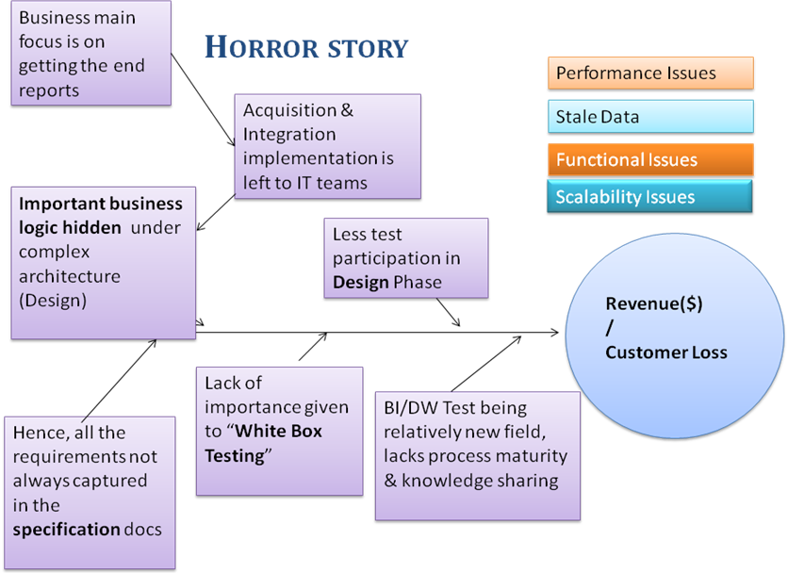

- Data volume and complexity grows over time
In this global economy, mergers, expansions and acquisitions have become quite common. Over a period of time, multiple sources get added and a single repository is constructed to consolidate all the data together at one place. Eventually as the data grows the complexity increases exponentially in terms of understanding syntax and semantics of the data. Also, the complex transformations logic to tackle this problem may further impact user query performance.

- Upstream changes often leads to failure
Any changes made to the design of upstream data sources directly impact the integration process, which further results in modification of the existing schema and/or transformation logic. This eventually leads to not to be able to meet the SLA on time. Another constraint lies in the availability of data sources due to any unplanned outage.

- Upstream Data Quality Issues
Lot many times, the quality of upstream data to be acquired itself is in question. It has been noticed that primary keys are not quite as unique as expected; also the duplicate data or malformed data do exists in source systems.

- Data Retention (Archival & Purge) Policy increase maintenance and storage cost
Data Archival and Purging policy is arrived based on the business needs and if the data is required for longer duration then the cost of maintaining this data gradually increases with time. Data Partition techniques need to be applied in order to ensure that performance doesn’t degrade over a period of time.

- Data Freshness required can be quite costly for NRTR (Near Real-Time Reports)
For many time-critical applications running in sectors like stock exchanges, banking etc. it’s important that the operational information presented in the trending reports, scorecards and dashboards presents the latest information from the transactional sources over the globe so that accurate decisions can be made in timely fashion. This requires very frequent processing of the source data which can be very cumbersome and cost intensive.

Proposed BI/DW Test Process

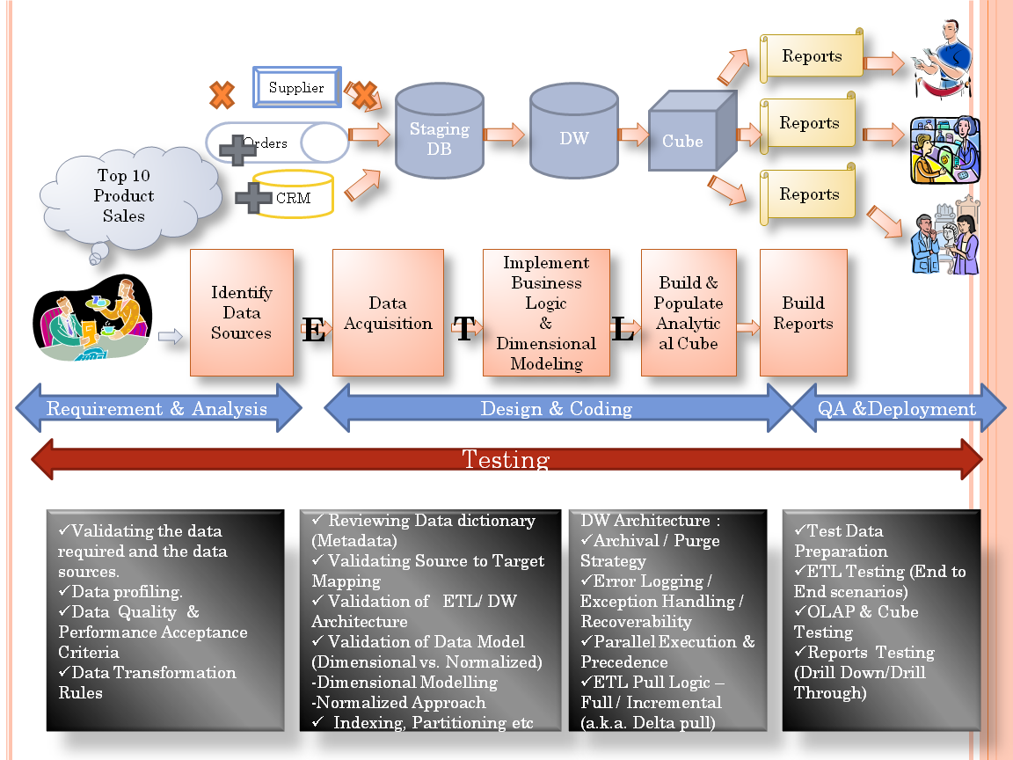
Design & Coding

Devising BI/DW Test Process
In the above sections we have witnessed the most commonly faced challenges in testing a BI/DW application. Here we are proposing a generic framework to test a BI/DW application which can be adopted across the industry. The following guidelines can be referred by the testing teams to determine the activities to be performed in each phase of SDLC.

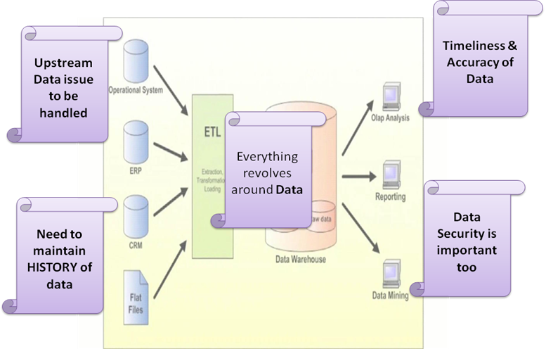

Requirements Review & Inspection:

Validating the data required and the availability of the data sources they can be acquired from.

      - Data profiling:
- Understanding the Data: This exercise helps test team understand the nature of the data, which is critical to assess the choice of design.
- Finding Issues early: Discovering data issues / anomalies early, so that late project surprises are avoided. Finding data problems early in the project, considerably reduces the cost of fixing it late in the cycle.
- Identifying realistic Boundary Value Conditions: Current data trend can be used to determine minimum, maximum values for the important business fields to come up with realistic and good test scenarios.
- Redundancy identifies overlapping values between tables.
Example: Redundancy analysis could provide the analyst with the fact that the ZIP field in table A contained the same values as the ZIP_CODE field in table B, 80% of the time.

      - Data Quality and Performance Acceptance Criteria:
- Data Quality attributes (Completeness, Accuracy, Validity, Consistency etc) e.g. A customer expects at least 90% of data accuracy and 85% of data consistency.
- Performance Benchmarking & SLA (Service Level Agreements) e.g. Report should be rendered in max 30 seconds.

Validation of Business Transformation Rules:
A realistic example for this can be to acquire last 5 years product sales data from United States for a Company (here this rule should be taken while designing the system as it doesn’t make sense to acquire all the data if the customer wants to see reports based on only last 5 year data from United States)

Test Planning
Every time there is movement of data the results have to be tested against the expected results. For every ETL process, test conditions for testing data are defined before/during design and development phase itself.

Key important Areas to be focussed upon:
- Scope of testing: Functional & Non Functional requirements like Performance Testing, Security Testing etc
- Testing techniques and Testing Types to be used.
- Test Data Preparation: Sampling of data from data sources or data generation

Design & Code Review / Inspection

- Reviewing Data dictionary
Verifying metadata which includes constraints like Nulls, Default Values, PKs, Check Constraints, Referential Integrity (PK-FK relationship), Surrogate keys/ Natural keys, Cardinality (1:1, m: n) etc

- Validating Source to Target Mapping (STM)
Ensuring the traceability from: Data Sources -> Staging -> Data Warehouse -> Data Marts -> Cube -> Reports

- Validation & Selection of Data Model (Dimensional vs. Normalized)

        - Dimensional Modelling:
Dimensional approach enables a relational database to emulate analytical functionality of a multidimensional database and makes the data warehouse easier for the user to understand & use. Also, the retrieval of data from the data warehouse tends to operate very quickly. In the dimensional approach, transaction data are partitioned into either "facts” or "dimensions".
For example, a sales transaction can be broken up into facts such as the number of products ordered and the price paid for the products, and into dimensions such as order date, customer name, product number, order ship-to and bill-to locations, and salesperson responsible for receiving the order.

- Star Schema:
      - Dimension tables have a simple primary key, while fact tables have a compound primary key consisting of the aggregate of relevant dimension keys.
      - Another reason for using a star schema is its simplicity from the users' point of view: queries are never complex because the only joins and conditions involve a fact table and a single level of dimension tables, without the indirect dependencies to other tables that are possible in a better normalized snowflake schema.

- Snowflake schema
      - The snowflake schema is a variation of the star schema, featuring normalization of dimension tables.
      - Closely related to the star schema, the snowflake schema is represented by centralized fact tables which are connected to multiple dimensions.

        - Normalized Approach:
In the normalized approach, the data in the data warehouse are stored as per the database normalization rules. Tables are grouped together by subject areas that reflect general data categories (e.g., data on customers, products, finance, etc.) The main advantage of this approach is that it is straightforward to add information into the database.

- Validation of BI/ DW Architecture :
Ensuring that design is scalable, robust and as per the requirements. Choosing the best approach for designing the system:

- Bottom-up:
Data marts are first created to provide reporting and analytical capabilities for specific business processes. Data marts contain atomic data and, if necessary, summarized data. These data marts can eventually be used together to create a comprehensive data warehouse.

- Top-down:
Data warehouse is defined as a centralized repository for the entire enterprise and suggests an approach in which the data warehouse is designed using a normalized enterprise data model. "Atomic" data, that is, data at the lowest level of detail, are stored in the data warehouse.

- Archival / Purge Strategy
Deciding on the appropriate archival and purge policy based on the business needs e.g. maintaining data history of last 5 yrs etc.

- Error Logging / Exception Handling / Recoverability
Ensuring appropriate data failure tracking & prevention (schema changes, source unavailability etc), as well as the ability to resume from the point of failure.

- Parallel Execution & Precedence
Data warehousing procedures can subdivide an ETL process into smaller pieces running sequentially or in parallel in a specific order. The opted path can have a direct impact on the performance and scalability of the system

- ETL Pull Logic – Full / Incremental (a.k.a. Delta pull)
Entire data can be pulled from the source every time or only the delta since the last run can be considered to reduce the network movement of huge amount of data for each run.

BI/DW Testing

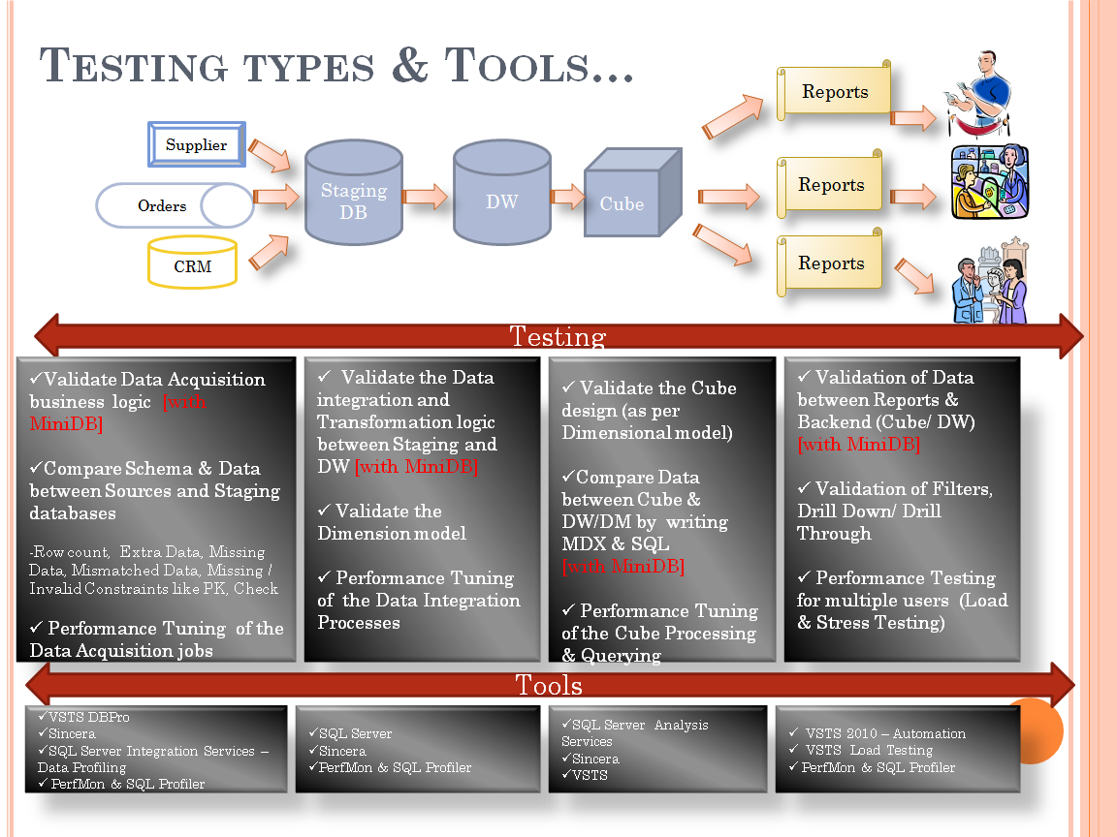

      - Test Data Preparation

- Test Data Selection
Identifying a subset of production data to be used as test data (Ensure that customer’s confidential data is not used for such purposes). The selection can be made on the following parameters:
        - On percentage, fixed number, time basis etc.

- Generate new test data from scratch
        - Identify the source tables, the constraints and dependencies
        - Understand the range of possible values for various fields (Include boundary values)
        - Use data generation tools to generate data keeping above rules in mind

      - Test Case Design & Execution

        - ETL Testing:
        - Validate Data Extraction Logic
        - Validate Data Transformation Logic (including testing of Dimensional Model – Facts, Dimensions, Views etc)
        - Validate Data Loading
        - Some data warehouses may overwrite existing information with cumulative, updated data every week, while other DW (or even other parts of the same DW) may add new data in an incremental form, for example, hourly.
        - Data Validation
        - Test end to end data flow from source to mart to reports (including calculation logics and business rules)
        - Validation of ETL Error Logs
        - Data Quality Validation
        - Check for accuracy, completeness (missing data, invalid data) and inconsistencies.

        - OLAP & Cube Testing:
        - Check whether the data from the data warehouse/data mart is mapped & designed correctly in the OLAP Cube or reports.
        - Validate all the measures and measure groups (including derived measures, aggregations)
        - Validate all the dimensions (including Slowly Changing Dimension), attribute hierarchy etc
        - Many OLAP tools provide on the fly computations features and provisions of customized SQLs, which can be prone to error.

        - Reports Testing (Drill Down/Drill Through)
        - Verification of the layout format per the design mock-up, style sheets, prompts and filters attributes and metrics on the report.
        - Verification of drilling, sorting and export functions of the reports in the Web environment.
        - Verification of reports containing derived metrics (Special focus should be paid to any subtotals or aggregates)
        - Reports with "non-aggregate-able" metrics (e.g., inventory at hand) also need special attention to the subtotal row. It should not, for example, add up the inventory for each week and show the inventory of the month.
        - The test team should target the lowest granularity that is present in the data warehouse if it is higher than the transaction grain at the OLTP.
        - Understand each report & the linkages of every field displayed in the report with the star schema and trace its origin back to the source System.

Closing Curtain

Testing BI/DW application requires not just good testing skills but also an active participation in requirement gathering and design phase. In addition to that, an in-depth knowledge of BI/DW concepts and technology is a must so that one may comprehend well, the end user requirements and can contribute toward reliable, efficient and scalable design. We have presented in this work the numerous flavours of testing involved while assuring quality of a BI/DW application. The emphasis lies on the early adoption of a standardized testing approach with the customization required for your specific projects to ensure a high quality product with minimal rework.

The best practices and the test methodology presented above have been compiled based on the knowledge gathered from our practical experiences while testing BI/DW applications at Microsoft.
Our forth coming articles would focus upon shedding light on areas like ETL Performance Testing, Automating an ETL solution, Report Testing, Data Integration Testing etc.

Authors

 | Raj Kamal is a Senior Test consultant (CSTE, Microsoft IT Professional SQL Server BI 2008 & ISTQB certified) specializing in different types of testing techniques, test automation and testability in different domains like Manufacturing, Healthcare and Higher Education. He holds an APICS certification in Supply Chain Management. Expertise with Rational and Mercury testing tools, he has helped teams develop test automation strategies and architectures for such companies as Cognizant Technology Solutions and Oracle Corporation.  He also provides training in automated testing architectures and design. He has a master's degree in Computer Applications. He is currently working at Microsoft, India, Business Intelligence COE. He has earlier represented Microsoft and Oracle at International test conferences as a Speaker.  Visit his Blog at www.itest.co.nr. Email: rajkamal@microsoft.com  Previous Stickymind contribution: Resurrecting the Prodigal Son--Data Quality
 | Nakul as a Senior Test consultant (Microsoft IT Professional SQL Server BI 2008 Certified) for Microsoft India – Business Intelligence Engineering team, is currently responsible for planning the testing of a large scale BI/DW application on SQL Server 2008 platform and in the past has led teams to test various products end to end.  He draws from his Master in Business Management from IIM (Indian Institute of Management, Calcutta) background to help organizations improve customer satisfaction, manage change, and strengthen process maturity. He also has specialized in training and consulting on testing, inspections and reviews, and other testing and quality-related topics.  Email: nakulm@microsoft.com

