Every Software Quality Assurance Professional finds that they bargain with Business Proponents, Development Engineers, Requirements Authors, and other QA resources in their attempt to define the risk of launching new features. Except possibly in instances where homegrown solutions have been crafted by expert test automation technologists, quality testing can be characterized like this:
- At best, tests are defined through classical, intuitive decomposition of requirements and/or specifications (if they exist).
- Test design is completed after the new application has been delivered for testing, so QA Test Analysts, can get the “feel” of the product, intuitively adding tests as required.
- Off-the-shelf automation tools require presence of the application for development of automation scripts.
- Where project management exists, timelines for QA testing never seem to be enough.
Thus educated guesses must be offered up to Business Proponents and Project Managers in answer to questions like “How much longer before we can release?” or “Haven’t we already tested the most critical stuff?”
And this describes a fairly advanced operation! Assuming the enterprise is working in some structure of defined formal process, and uses at least a semi-formal technique to define tests, the next step is usually evaluation of third party test automation tools. Most test automation novices (including the author at the time) feel that training their QA Tests Analysts in record-playback techniques is enough to get a decent start.
Project time crunches, expense of manual test coverage, and a perceived need for reproducible accuracy drive QA management to see the need to automate as obvious. However, achievement of realistic and sellable time lines, reduction of ongoing test expense, and enhancement of reproducible accuracy seems to remain elusive even as the Quality Team matures.
Why?
Project timeline ambiguity roots itself in two major areas. First is the ability to define when test coverage will sufficient to adequately define risk before the features are launched (test strategy). Second is the time it will take to implement and complete the tests developed to identify risk (test implementation tactics). See figure 1.
Figure 1
Automation goes a long way in identifying risk to features already serving an enterprise’s customers. So record-playback techniques are very attractive to quality managers seeking to define risk in a predictable time frame. It’s a way to draw a baseline that can quickly identify whether the next launch is going to risk customer loyalty that was built upon existing functionality.
In an environment where the GUI remains fairly stable (as in shrink-wrapped GUI applications) these efforts can produce desired results fairly quickly. Major feature release cycles can be in the 4-12 month range. Also, subsequent feature releases will probably not significantly alter previously defined user interfaces, so the tests will continue to work.
In the rapidly evolving e-commerce marketplace, the demand for feature (as opposed to content) release frequency can be as little as one week, possibly even less. Critical defect patches must sometimes be developed and deployed in 1-2 days, or even hours. In this environment, automated testing is effective only with test scripts where a very high level of script componentization has evolved.
Componentization allows the automation technologist to adapt many tests to the new release with the least amount of effort. That is, s/he can make one “fix” that affects a number of tests.
In an environment where record-playback has been employed, there is little-to-no modularization, and the scripts have been authored by QA Test Analysts who may have had no automation training beyond record-playback. So tests that rely on common, but changed application interfaces or functionality must be repaired test by test. In doing this, QA resources spend a lot of time fixing the same thing in several tests. As new tests are added, the venture quickly reaches a point where further automation under the record-playback discipline becomes cost prohibitive. This break point is reached more quickly as the frequency of feature releases increases.
So as the enterprise matures, test automation either becomes more modularized or the automation effort is abandoned because it has become too complex for the existing QA team to manage. The latter occurs because the return on investment (ROI) opportunity with test automation seems to have disappeared.
The second area of ambiguity occurs with regard to test definition. It can simply be defined with the question, “When will the test cases be of sufficient quality to adequately identify risks associated with the launch?”
To date, test definition has been largely intuitive, even when following a classic decomposition regimen. So the QA Test Analyst is confronted with estimating the number and quality (coverage) of tests that will provide adequate risk identification, as well as the time it will take to define them. The analyst delivers an answer that will almost certainly depend upon when new features will be delivered to QA for testing.
Timeline crunches are notorious for sacrificing the overall quality of testing for the sake of accelerating time-to-market. Time-to-market is almost always driven by the need to open new or enhance existing revenue opportunities.
Sometimes business proponents don’t fully appreciate that delivering poor quality to market can be more damaging to a revenue opportunity than delaying the launch. Can you really say you made it to market on a specific date when the features must be pulled for repair, then re-released at a later time?
A primary element that drives timeline extension is the perceived need by the test analyst to see the application, thus generating a dependency upon code delivery. In the absence of complete and unambiguous requirements, this dependency is accentuated.
So now we’ve arrived at the realm of process. Most experienced quality managers understand that risks begin in the requirements. In fact, studies have found that as many as 80% of defects are rooted in design and in design articulation through ambiguous or incomplete requirements. At Egreetings Network, Inc., the quality team reduced post-launch discovery of defects by about 80% after requirements testing practices were instituted for the first time.
Descriptions of the “ultimate” QA practice usually include some form of testing applied to the requirements. I think you’d agree that most code developers, development managers and QA professionals nod their heads in vigorous support of this concept.
Two practices serve to test requirements: first, the engineering effort, and secondly, the test analysis and definition endeavor. In organizations facing quality problems, these efforts probably remain isolated. Thus, when code is delivered, disparate interpretations in the requirements are discovered: one held by the business proponent, another by the software developer, and possibly a third held by the QA test analyst.
Unfortunately, this discovery usually occurs after code has been delivered for QA testing, and likely represents a serious design flaw. Consequently, timelines defined in the project plan are at serious risk (revenue), not to mention development budget allocations (cost).
This begs the question, “Can QA’s work can be leveraged to eliminate or mitigate risks to launch and timelines (revenue) as well as those associated with design problems (cost)?”
Two business enterprises benefited from this practice: Egreeings Network, Inc., and Wells Fargo Bank, Business Object Services (BOS). BOS developed and deployed the Common Object Request Broker Architecture (CORBA) layer for Wells Fargo.
In both cases, requirements quality improved and the number of test cycles diminished. This manifested most dramatically at Egreetings because the test effort covered all application tiers simultaneously. At Wells Fargo, the practice had been limited to the CORBA middle-tier exclusively.
Improvement in requirements was reflected by shorter development efforts because design problems were identified frequently prior to development. When conducted in parallel with engineering’s UML (Unified Modeling Language) analysis practice, the QA team in partnership with engineering was able to identify these risks before coding began.
This proved to be very valuable in forging an alliance with engineering, with QA acting as engineering’s advocate for complete, concise, and unambiguous requirements. In turn, engineering quickly learned the value of this alliance. Development interactions grew toward close cooperation among engineers and QA test analysts. This occurred both at Wells Fargo Bank, and at Egreetings, Network, Inc.
Figure 2
As business proponents were challenged by ambiguities articulated as questions, their respect and knowledge of the development process deepened. Most evident was the need for cooperation in forming and maintaining requirements, including complete and timely communication among cross-functional teams. This served to meet time-to-market while identifying, thus minimizing risk. A three-legged stool is a good metaphor to illustrate this relationship.
Interestingly, the core practice that generated this synergy of cooperative process was the QA team’s work with an old, but relatively unused practice.
Developed at IBM over 30 years ago for the purpose of testing logic gate functionality on processing chips, the technique was adapted successfully for black-box software testing. Central to this practice is development of a Cause-Effect Graph (CEG) which effectively prototypes the state flow for proposed features. Such graphing successfully captures logical relationships, including constraints between inputs and outputs.
A major benefit over traditional intuitive decomposition is that the rigor introduced through authorship of the CEG has a definite end: when the graph is complete, it successfully describes the functionality articulated in requirements. This is a very apparent and verifiable milestone. So unlike the intuitive approach, additional tests are rarely, if ever discovered after launch.
That means test coverage is complete. And completion of test design with reliable coverage becomes a known milestone. Under established process and consistent practice the definition of reliable and comprehensive tests grow to be more predictable. Thus project management implications become very significant.
Rigor achieved by this discipline drives discovery of inconsistencies, ambiguities, and omissions in requirements documents. Thus, a reliable and effective flow of conceptual discussion and resolution is initiated that helps establish cross-functional collaboration.
Additionally, completion of CEG analysis is easily achieved before code completion by experienced practitioners when conducted in parallel to engineering analysis in support of actual code development.
Another way of achieving coverage is referred to as “combinatronics-based” testing. Here a test analyst knows when their work is complete. However the technique does not guarantee full functional coverage because the number of test cases generated is un-manageable.
As an example, let’s say that an application has 37 inputs. This technique would yield an exhaustive test suite of 130 billion possible combinations. Which ones should be implemented? Time and cost constrains obviously prohibit further pursuit of this strategy. So you find yourself right back at the intuitive model (trying to pick the right tests to implement).
Applying a defined and accepted mathematical algorithm against functionality expressed in the CEG provides test analysts with the capability of systematically identifying the fewest number of tests that employ full functional test coverage. For example, this number works out to 22: a very manageable test suite.
At Egreetings, test analysts discovered eight substantial design errors before engineers began coding during a critical project. For ease of reference, this will be referred to this as Project “A”. If the flaws had been discovered subsequent to code delivery, the Project “A” could have been delayed for as long as two months. In the business context of this project, the effort would have been cancelled and the very significant revenue opportunity completely lost.
Approximately 300 test cases were defined about three weeks before the application was delivered for testing (a system problem had delayed code delivery by two weeks). Engineers were given the test cases so that they could enhance their unit test effort.
In all, the collaborative analysis forged an effective partnership among requirements authors, engineers and test analysts. This practice successfully identified serious design flaws early enough for economic correction. Economic not only in bottom line costs, but also in delivery time.
LIZ
COMMENTS about Engineering’s shift in perspective regarding EGRT’s QA effort and personnel… after discovering that (?)
- Their code would be tested competently & comprehensively. (?)
- Their task was simplified by having QA’s assistance in holding the BP responsible for clear & unambiguous specs (?)
- That they could more effectively unit tests using the English-language test scripts that were available to them (?)
- Something else not mentioned here (?)
What did engineers expect from QA before? What were these conclusions/expectations based upon?
What did they come to expect? Why?
What initiatives did engineers want to launch after perceiving the value that QA added? (e.g. Unit Test & Unit regression test services?).
Did engineers more thoroughly unit test when they knew their code would be tested using these techniques?
Did more thorough unit testing decrease the number of bug-fix cycles?
Anything else?
THESE COMMENTS SHOULDN’T INCLUDE AUTOMATION—I THINK. See second “LIZ COMMENTS” box.
Because test analysts provided invaluable feedback that saved the project, their work was consumed with respect and anticipation by all functional groups. This dynamic served to strengthen adherence to process by educating all participants through hands-on experience.
Effective capture of statistics, including enumeration of high-risk ambiguities, pre- and post-launch defect discovery counts were essential in dramatically representing advantages of this practice to the business enterprise as a whole. These data were contrasted against the business’ performance before this strategy had been employed.
Statistics proved the effectiveness in defining the 300 Project “A” quality tests. In the first week after launch, no application errors had been discovered. The problems documented after launch related exclusively to configuration differences between production and test environments. These differences pointed to defects in the software deployment process.
Collaborative efforts among cross-functional teams allowed engineers to produce code with fewer defects. So the number of planned code drop (bug fix) cycles was reduced from what had been estimated in the project plan. This allowed for feature delivery to the market nearly a week before schedule. Had an unfortunate loss of source code not occurred during development, the project would have been delivered three weeks early.
Project “A” projections were based upon earlier efforts that had not fully benefited from these practices.
Figure 3
Figure 3 represents an example of pre and post defect discovery rates against the first large project subjected to these techniques at Egreetings Network, Inc. For future reference in this article, it’s referred to this as Project “B”.
Project “B” was successfully launched nearly a year before Project “A”. The average post-launch defect discovery rate against this project was about 2 defects per weekly feature release.
In this early implementation of the requirements-based testing practice, the team had not yet differentiated between application errors and those generated by environment issues and deployment problems. At this stage of the business’ evolution, optimization of deployment practices had not been addressed. For this reason, the actual application error rate was less than the reported average, probably less than 1 per release.
Typical post launch defect discovery rates during this period averaged an estimated 5-6 per release. This accounts for the approximate 80% reduction mentioned previously. 5-6 undiscovered defects per release was characteristic of parallel development projects subjected to intuitive test design. All projects were tested manually at this time.
More often than desired, these late discoveries meant that defective features had to be recalled for repair and re-launched with a later release. Such activity denied or delayed revenue opportunity.
Please also note the persistent decline of defect discovery in figure 3 as Project “B” progressed. Interviews with software engineers, QA test analysts, and business proponents revealed that the most complex portion of the project occurred at the beginning. However all agreed that the discovery rate also declined as they learned and redefined process, improved communication, and corrected the most common errors discovered through their collaboration in this discipline. It’s easy to see how this assisted in controlling costs while shortening time-to-market. This was the first large project launched on time.
Figure 4
Figure 4 shows pre and post defect discovery to the site as a whole. Project “B” occurred near the end of this period, while several other features were released in parallel. All tests were manually executed. Only the tests associated with Project “B” were generated using requirements-based testing techniques.
These statistics, which did not differentiate among application and deployment errors, averaged 7 for the last three weeks. Accounting for the deployment problems at that time, it would be easy to justify an adjustment of the number to 5 or 6.
Figure 5
Another trend can be seen in the approximate averages produced after assignment of additional testers. Even though testers 6, 7, and 8 began on the same day, their efforts did not increase regression test coverage. In fact, if the number of anticipated projects not increased in the queue, there would have been no need for these additional test analysts.
So the QA team’s implementation of CEG authorship from requirements analysis, in conjunction with collaborative work among cross-functional groups proved the effectiveness of this practice.
It was apparent that failure to effectively employ test automation would represent a significant loss, and would not maintain the low post-launch defect rates enjoyed against new projects. It was critical to develop the business’ ability to fully leverage this significant domain knowledge investment against subsequent releases.
The next step was to purchase off-the-shelf test automation tools. Because the team lacked expertise in working with these tools, a “quick-start” consulting package was selected.
In the midst of implementation, it became painfully apparent that record-playback techniques would not produce sustainable test automation, even by the experienced quick-start technologists. The web application was simply too volatile. By the time tests could be adapted to the last release, the next release needed to have been tested and deployed.
So there arose a conundrum. It seemed reliance on automated testing to simply shake out the new release, exercising “go-good” core functionality would sacrifice low defect rates. By this timenearly 500-600 test cases had been accumulated. To maintain the low defect rates, these tests had to be executed for each feature release.
And Egreetings largest project yet was looming: complete rearchitecture of the entire application. Every line in the application was being re-written in a migration from procedural CGI scripts to object-oriented (O/O) Java applets & servelets.
The decision was made to test a feature-frozen legacy application with a minimal manual effort, while solving the automation problem in parallel to test development for the re-architected product.
A further decision was made to fund further development of software tool that showed promise in solving the automated test script maintenance problem within web based e-commerce applications. In excess of 700 test cases had been forcasted for the new application. The cost projections based on experience spoke loudly! It was clear that even a significant investment in developing SpiralTest would support a decent ROI. See figure 6.

Figure 6
We had experience with costs associated with manual regression testing. It was clear that this model was also not sustainable because of its cost. Pursuit of manual testing would mean removal of resources from this task and compromise test execution coverage. The low defect rate could not be sustained. Also, manual testing only seemed more nimble than traditional automation. This was an illusion because repetitive execution of so many tests was fraught with human error.
With the onset of rearchitecture and the problems encountered when attempting to apply traditional automation to the legacy site (described above), the traditional automation course of action was abandoned.. The figures above remain an estimate.
Initial cost projections with regard to SpiralTest assumed about 700 automated tests and was more pessimistic than that shown above. Figure 6 represents the actual overhead costs realized after implementation of about 1100 automated tests. Ultimately, 1400+ test cases were automated.
SpiralTest offered the opportunity to realize effective leverage of test cases already defined in the course of previously launched products.
But returns did not stop there. Because this is a test maintenance tool, the team was also afforded the ability to define new tests immediately upon completion of requirements-based test development work products.
Because SpiralTest is basically a database of very highly modularized test script functions, it could represent several models (versions) of the website, both past and future with icons. The icons were used to represent user interface objects and object collections on the web site. Each user interface object (text link, image link, text edit field, button, check box, radio button, and text copy) possessed attributes that, when passed on to the third-party test execution tool, allowed the tool to recognize the object used in a test.
Thus, immediately upon completion of test case definition, and with a UI specification in hand, test analysts were able to immediately define a “should be” view of UI objects and UI object collections, including tables and table cells.
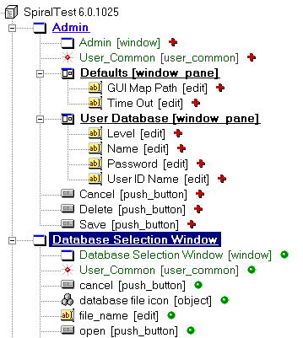
Figure 7
The collections of “as is”, “as was”, and “should be” icons were named “Object Trees”. See the example of a portion of SpiralTest’s object tree in figure 7, above. The “should be” version of an Object Tree was built. The new tree was based upon inheritance from the previous version with additions and changes from requirements and specifications, these objects were used to instantiate specific test steps. This is how fully automated quality tests capability was managedbefore application delivery for testing.

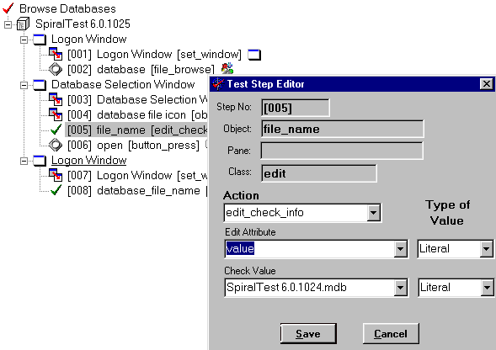
Figure 8
Figure 8 is an example of a test case defined from the Object Tree. As each object is imported from the tree, the user is prompted with a dialog box that allows the test analyst to define a specific instance of the object’s actions and test data values within a unique test case. Specific test steps can be modified at any time. In test step 5, above, the script is generated to verify that the value “SpiralTest 6.0.1024.mdb” was correctly entered in the edit field by the preceding test steps.
If you recall, the team lacked expertise in working with 3rd party test automation tools. With only two hours of training, non-technical, but highly accomplished analysts were automating tests.
Once tests are defined as illustrated in figure 8, English test narratives and test tool scripts were generated. Figures 9 and 10 are examples of these work products.
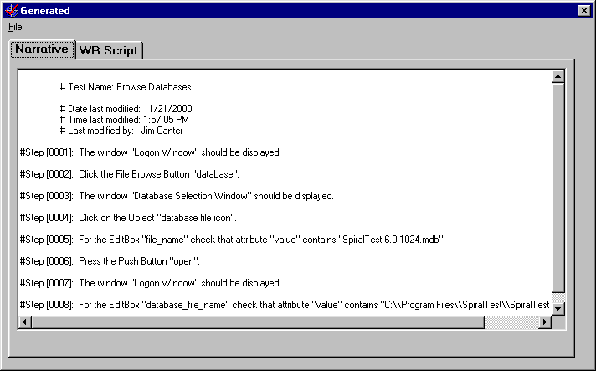
Figure 9, Generated English Test Narrative
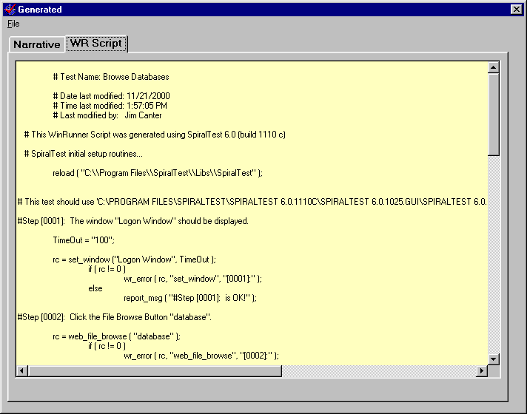
Figure 10, Generated, and Fully Commented Test Execution Script
With this capability in place, a new important milestone surfaced that project managers used very effectively. Because all functional quality testing had been automated (even for the first code drop), QA test analysts were free to move on to the next project, supporting the last project with minimal effort. A new milestone was defined: “All tests run once”.
Achieving this milestone told the entire organization that the team had completed identifying the launch risk. It told project managers that QA resources were now free to participate in subsequent projects. It told the development engineers and QA test analysts that there were no defects that blocked test execution. It told the business proponent that they could shift to focusing on defect priority and severity decisions, finally identifying remaining “showstopper” defects. From that point on, remaining team members worked with engineering to resolve and verify fixes to these showstoppers.
In Project “A”, where no application defects were discovered two weeks after launch, this milestone was reached on the second code drop. From that point on bug testing and repair experienced very rapid turn-around cycles.
Cross-functional development teams experienced the same learning curve discussed concerning figure 3, above. So, the project forecast for bug-fix cycles was beaten not only in number, but also in turn-around time.
What about test maintenance?
As you could probably guess, a percentage of existing tests were broken with each feature release, some were broken with content releases. The database proved extraordinarily effective in applying the O/O principle of re-use. This meant that once a shared Object Tree object was identified as changed, dependent test cases could be re-generated and deployed immediately on-the spot.
The tool’s impact analysis capability was formidable. Figure 11 is an example where the tool reports what tests depend upon the use of the “Database Selection Window” object. Please notice that the “Generate Tests” button immediately deploys fixes applied to this object to all affected tests.
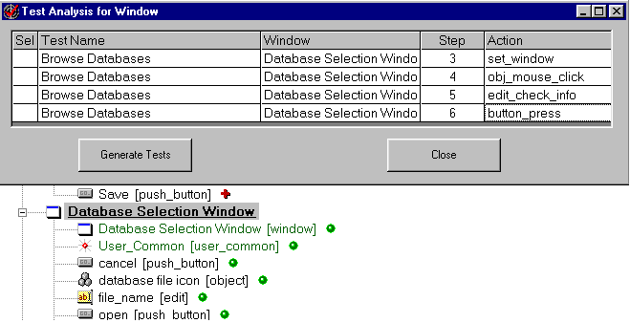
Figure 11, Test Impact Analysis
This was the key feature that so dramatically reduced cost over traditional automation. It also freed technologists to pursue white-box and custom test automation development (in UNIX script, and Java), and in further automating test result reporting.
In fact, one month after launching the re-architected site, the content was subjected to a complete re-design. That meant that all content templates were changed. Since black box automation accessed the middle application tier through the User Interface, ALL 800 tests were broken.
We had the last week (5 days) of a two-week feature and content freeze to recover. It was done. The next feature release was subjected to a fully automated regression test. The week after that, project “A” was launched.
Project “A” tests were automated originally under the legacy templates. Those 300 tests were converted in time for launch as well.
The goal of being nimble, thus responsive to a volatile development environment driven by a capricious marketplace. The ability to maintain very low defect rates at a much lower cost was achieved.
Because the tool freed QA resources, elimination of manual regression testing was complete.
So Egreetings migrated from
- Tests defined through classical, intuitive decomposition of requirements and/or specifications.
- Test design completed after the new application has been delivered for testing
- Use of off-the-shelf automation tools requiring presence of the application for development of automation scripts.
- Timelines for QA testing never seemed to be enough.
To an environment where:
- Tests were designed scientifically from requirements, assuring complete functional coverage
- Test design was complete before the application was delivered for testing
- Off-the-shelf test automation tools allowedfull automation of new tests before the application was delivered for testing
- QA was removed from the critical path in the timeline
Additionally,Egreetings
- Established and evolved a process that was probably more cost effective than the compay’s competitors’, and at the same time
- Maintained exceptionally high quality with
- Shortened time-to-market, and
- Generated organizational support for
  - Requirements capture and articulation with early QA practices
  - Refined and more effective project management practices by establishing important, measurable milestones.
LIZ COMMENTS
What was the impact on engineering when their first code drop could be tested with automated tests?
What action(s) did this kind of QA turn-around spur?
For requirements-based testing, TBI’s CaliberRBT tool was employed. Automated test execution was accomplished using Mercury Interactive’s WinRunner. Test execution management and reporting used Mercury Interactive’s Enterprise TestDirector.
What would this mean to a development environment that is less advanced initially?
Software quality managers now have an option to initiate a self-funding effort to deal with quality issues. For applications that are already in consumer hands, SpiralTest offers the capability of quickly automating existing tests regardless of their origin (requirements-based or intuitively composed).
With these tests in place, QA resources are freed to pursue enhancement of test coverage, preferably by implementation of requirements-based testing.
If a professional quality manager can generate support for this seed of process enhancement, quality benefits can evolve as the business recognizes real gains.

Requirements-Based Tutorial, Bender & Associates, January 1999
Requirements-Based Tutorial, Bender & Associates, January 1999

