Metric-based Test-oriented Approach in Prototyping SDLC

-Ranjit Shewale

E-mail: (jcrvs@hotmail.com)
Dated: January 21, 2003

Table of Contents

1.1 Abstract 3
1.2 Metric-based Test-oriented cycle (that includes the prototyping model) 4
1.2.1 Metric-based Test-oriented cycle 4
1.2.2 Details 5
1.2.3 Assumptions 5
1.2.4 Advantages 5
1.2.5 Drawbacks 6
1.3 The development and test phases in prototyping life cycle 7
1.3.1 Phases 7
1.3.2 Prototyping cycle details 8
1.3.3 Test-oriented model 10
1.3.4 Comparisons with the conventional V-Model 11
1.3.5 Deviations observed with the conventional prototype model 12
1.4 Conclusion 13
1.5 References 14

1.1 Abstract

This paper describes the metrics-based test-oriented approach used in a project that followed the prototyping software development life cycle for Web application development. This test model resembles the V-model of testing in some respects. This model, in addition to the V&V activities, also involves client verifications in some phases. This prevents further chaos and confusion in project development. The test oriented metric collection is a marked activity of the approach.

1.2 Metric-based Test-oriented cycle (that includes the prototyping model)

1.2.1 Metric-based Test-oriented cycle

Figure 1.1 depicts the metric-based test-oriented cycle.

Prototyping Software development life cycle

Client
Collect metrics
Project 1 following prototype model of SDLC
Consulting company

Management

Project 2 following prototype model of SDLC

Metrics Repository

Feedback Loop

Fig 1.1

1.2.2 Details

The metric-based test-oriented cycle is the model outlined here. This model applies to consulting companies executing multiple projects in the same technology area. The prototype SDLC and the feedback loop are integral to the model.

This approach is based on the assumptions mentioned in section 1.2.3. The consulting company (as shown in the following figure) executes projects to develop software for its clients. For the first project, company-specific process (that includes test estimation) is followed. This estimation and execution of projects are ideally based on the experience of the manager and the project leaders for the first project. Test-specific metrics collection is a marked activity for the project cycle.

When the project is being executed, test-oriented and other project metrics must be collected (more of test metrics in our case) and inserted in the metrics repository. For metrics details, refer to the document Feedback_loop. After successful execution of the project, when the client starts work on the next project with the consulting company, the metrics data is an ideal source for estimation and planning. Also, by then, the client is already aware of the prototype SDLC model. (Client aware of software engineering practices is always a better proposition.) For a sample estimation sheet based on this empirical model, refer to Test estimation in prototyping SDLC.xls in the References section.

1.2.3 Assumptions

- The prototyping model of software development is being followed for project development.
- The consulting company is developing software for the same client over and over. (i.e.consulting company is executing multiple projects for the same client by using the same technology).
- A minimum of one test resource is involved right from the requirement-gathering phase. It is recommended to have a senior test resource or a test leader for the purpose.
- The documentation approach for the test cases remains constant throughout projects

1.2.4 Advantages

- The empirical model for the test estimation is derrived from the metrics data and can have minimum deviations.
- If the same project team is maintained, results can be achieved with close deviations.

1.2.5 Drawbacks

- The first project is devoid of empirical estimation based on metrics.
- The empirical estimation approach may not be the finest approaches for test estimation.
- The empirical estimation approach is suitable for the prototype model with single iteration (as the waterfall model) for the projects executed. It needs to be scaled to fit the spiral or other models.
- It is difficult to maintain the same set of people in the team, including the testing team. Companies usually are short on particular resources . This can greatly hinder project management.

1.3 The development and test phases in prototyping life cycle

1.3.1 Phases

The various phases observed in this prototype model and the corresponding test phases with appropriate client intervention and responses are outlined in the following table.

Development Phases | Test phases | Client Interaction
Requirement phase and clarification | Test lead involved in the phase along with the development team | Client delivers the business requirement document
Overall project estimates and project plan | - | -
Prototype development (Mock HTML development) | Mock test, test plan, test estimates (preliminary version) | Mocks delivered to the client for sign-off
Re-estimates and revisiting the project plan | Test re-estimates and revisiting the test plan | Estimates and plan sign-off by the client  Test plan sign-off by the client.
Design phase – Design/Functional document/Database design documents | Unit and system test case preparation phase | Client sign-off for the design documents, unit and system test suites
Coding | Unit and system testing | -
Bundle and release | Installation testing | Client installs and acceptance test, followed by sign-off
Maintenance | Re-test | Re-deliver, re-test, and client sign-off

This SLDC is part of the Metric-based test-oriented cycle depicted in Fig 1.1.

1.3.2 Prototyping cycle details

The prototyping cycle consists of the following phases:

- Requirement and clarification phase
- Overall project estimates and project plan
- Prototype (mock HTML) development
- Re-estimating and revisiting the project plan
- Design phase – design/functional/database design documents
- Coding and testing
- Bundle and release
- Maintenance

During the ‘requirement and clarification’ phase, a team comprising at least one test engineer is formed. Conventional methods of requirements gathering and information/issue resolution are used.
Entry criteria:
- Business requirement document provided by the client.
Exit criteria:
- Comprehension of the requirements
- Compilation of a list of the issues/queries raised and their resolution
- Creation of use-cases and/or diagrams, if any

During the ‘overall project estimates and project plan’ phase, overall project estimate and project plan are prepared.
Entry criteria:
- Business requirement document
- List of issues/queries raised and their resolution
Exit criteria:
- Project estimate
- Project plan

During the ‘prototype (mock HTML) development’ phase, the graphic user interface for the HTML prototype is designed, tested, and submitted to the client. The client sign-off is necessary for the project to proceed to the next phase. The requirements team works in close coordination with the design team. The testing team plans tests and comes up with the test estimates to be verified by the manager.
Entry criteria:
- Business requirements document
- A list of issues/queries raised and their resolution
- Project plan
Exit criteria:
- Client sign-off for the HTML prototype

During the ‘re-estimation phase’, the manager revisits the estimates and redraws plans based on the inputs received from the team and the HTML prototype. The test estimates are also revisited as a separate activity (in second project when the test metrics are available from the first project. This setp is does not exist for the first project since the metrics data does not exist). The master estimation tecniques/templates may be modified/ updated for the deviations or corrections found in the same.
Entry Criteria:
- Business requirements document
Exit Criteria:
- Project plan (re-visited)
- Project estimates (re-visited)
- Test estimates (re-visited)

The ‘Design’ phase involves database design and detailed functional design of the product based on the HTML prototype. Details regarding the functionality and the actors interacting with the system are also worked out during this phase. In other words, it involves revisiting the prototype design and working out a low-level design based on the technology used to develop the product. The test team gets involved with the development of test suites based on initial design documents and mock-up HTML pages. For templates used for unit testing and system testing that can facilitate this approach, please refer to the Reference section.
Entry Criteria:
- Business requirements document
- Project plan
- A list of issues/queries raised and their resolution
- Use cases, if any
Exit Criteria:
- Database and functional document submitted to the client
- Unit and system test suites submitted to the client

During the ‘coding and testing’ phase, the proposed system is coded and tested. Test teams and development teams work closely with one another. This phase involves coding, code reviews, unit testing, and system testing. Appropriate configuration management processes are followed. This phase also involves metrics collection.
Entry Criteria:
- Database and functional document signed off by the client
- Unit and system test suites signed off by the client
Exit Criteria:
- Code
- Unit and system test logs
- Defect sheets

During the ‘bundle and release’ phase, the last stable and properly tested release is bundled. This involves the code, binary images, and installables, if any. The bundle is verified by performing the installation test and binaries. Appropriate release notes mark the end of the release.
Entry Criteria:
- Unit and system test code ready
- Defect sheet marked with closed bugs
Exit Criteria:
- Test team ascertains that the product is bug-free and meets requirements
- Installable bundle and release notes shipped to the client

At this point, the client installs the application and it undergoes the acceptance test on the client side.

During the ‘maintenance’ phase, client-side bugs are fixed, assuming that they are not functional deviations as mentioned in the business and the design document). These are tested and the patch release is sent across to the client.
Entry Criteria:
- Code release to the client
- Client installs the system successfully
Exit Criteria:
- Client signs off the project

This is followed by a feedback loop at the consulting company to update the estimation techniques and other processes based on the metric data collected for this particular project technique and SDLC model. The test-specific, organization-specific, and project-specific data is collected.

1.3.3 Test-oriented model

The model promotes early involvement of the test personnel in this cycle that facilitates comprehension of the client business and its processes. This reduces the learning curve. The early involvement also gives test engineers a chance to participate in the project development life cycle. Better comprehension of the business helps them to validate requirements in a better manner.
The test engineer works with the development team from the requirements phase till the end, apart from performing conventional activities (test planning, documenting test cases, testing, and so on) involves in the activities as:
- test tool evaluation,
- business comprehension (to find the most use software part of the system)
- quality processes
- metrics collection (the metrics are targeted to test process)
- configuration management
- evaluating automated approach for testing
- planning strategies to reduce the test preparation and execution timing ec.

Since the metrics are more inclined towards the test process, the Feedbacl loop and the Test estimation in prototyping SDLC excel sheet gives a good idea for the same.

1.3.4 Comparisons with the conventional V-Model

Figure 1.2 depicts the conventional V-model.

The following deviations have been observed:

- The acceptance phase is marked as a client-side activity and is therefore considered out-of-scope.
- The requirements and the analysis phases are clubbed as the ‘Requirement Phase and Clarification’ phase.
- During the new ‘Overall project estimates and project plan’ phase, the estimation takes into account the efforts required to create the prototype or HTML mock-ups of the product.
- Integration tests are scattered in the unit test suite and the system test suite.
- The prototype model followed for the projects is internally similar to the waterfall model and is not iterative in nature.

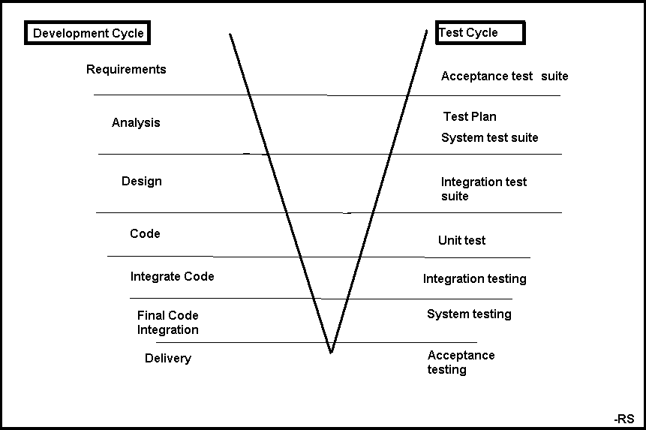
Fig 1.2

1.3.5 Deviations observed with the conventional prototype model

The prototype life cycle model being followed that is part of the test-oriented model fits the conventional prototyping model with a few exceptions as follows:

- The prototype comprises HTML mockups and provides product format, style sheets, and graphic effects to the design phase. Since the product itself is a Web system in the HTML format, partial design (in terms of UI) is complete and does not have to be scrapped completely.
- The integration test cases are scattered partially in the unit test suite and partially in the system test suite.

1.4 Conclusion

The test-oriented approach can effectively work along the prototype model with certain assumptions. It does not yield immediate results but over a period of time the metrics data proves useful. Certain deviations may be observed when this approach is applied to other technology projects. The organization maturity also plays an important role in the efficacy of this approach. The metrics data may lead to improper results at times and hence should be used wisely.

1.5 References

- Test estimation in prototyping SDLC.xls
This document provides details of the estimation sheet created on the basis of the metrics collected in few projects using a particular technology. A sample estimation calculation is also documented.
- Projectname_STC_application.xls
This document is a template used for documenting system test cases. The template can be used effectively in projects where the time-to-market is very less.
Projectname_UTC_jsp-name.xls
This document is a template used for documenting unit test cases. The template can be used effectively in projects where the time-to-market is very less.
- Feedback loop.doc
This document provides details of the feedback loop that is executed using metrics and feeds essential information to the company and the project that can be used to access/improve the test process and test estimation for further projects.

The aforesaid documents can be found at www.stickyminds.com. Alternatively, send an e-mail to the author to obtain a copy of the same.

