“Establishing and Implementing Software Quality Assurance”
-- Arati Prabhakar, IonIdea Enterprise Solutions Pvt Ltd, Bangalore.
Abstract
With increasing demand for software products with high ‘Quality’, it has become imperative for organizations to adopt quality models like ISO 9001, SW-CMM, SPICE, CMMI, or Six Sigma etc to set and sail on their Quality journey. The strong emphasis on Software Quality Assurance in these models coupled with the modern day mantra of “Prevention”, the need for pro-active Quality Assurance is higher than ever.
Software Quality Assurance is a planned and systematic approach necessary to provide adequate confidence that an item or product conforms to established standards, procedures and policies.
This paper addresses the Quality Assurance practices that were employed in the organization to assure “Quality” of Software Product Development. It describes the practices that can be effectively adopted both at the project level and organization level. Defect Metric data which has been collected out of this endeavor is also presented.
Introduction:
One of the most important parameters that need to be managed as part of a project is software “Quality”. This involves good Quality Planning, Quality Control and Quality Assurance practices to be in place. At IonIdea we believe - "When Quality is in your Mind, it shows in your Work."
It is said that “You can do it right, or you can do it over again” The ‘do it over again’ has significant cost concerns associated with it. For example if a bug found during the development phase costs $1 to fix, then, if found in Unit Test, it costs $10; if found in System Test, $100; and if found in the field, $1000. The exact numbers are arbitrary but the order of magnitude effect is not. The answer to this -- “Find bugs earlier “. This is the essence of Software Quality Assurance which is an effective technique adopted by organizations in order to build products of good Quality.
Rationale behind IonIdea’s Software Quality Assurance
Fundamentally at IonIdea, the SQA function is concerned with achieving Quality through greater visibility and greater communication about how the customer’s requirements are transformed bit-by-bit into a functioning software product. Unlike a large part of the software industry, the SQA function at our organization is not at all equated to testing activities and is in fact concerned with process adherence, independent project progress monitoring with orientation to ‘prevent’ than detect the errors that are already built in to the product.
IonIdea supports the practices of high maturity organizations and has adopted the model of having an independent SQA as well as embedded SQA in process. The SQA group focuses on the process monitoring and the product assurance is in built in project peer reviews and audits.

Software Quality Assurance
Definition:
- Software Quality Assurance is an umbrella activity that is applied at each step in the process of building the software. It is a planned and systematic set of activities necessary to provide adequate confidence that requirements are properly established and products or services conform to specified standards.

QA can be provided usually by an independent organizational unit but need not always have to be. Quality is assured internally to the Project team and Management and externally to the Customer.
Software Quality Assurance as per CMM
SQA is a CMM Level 2 Key Process Area which elaborates the activities to be performed as part of QA.
Interpretation of the Key Process Area “Software Quality Assurance”:
- The activities of Software Quality Assurance are performed as per an organizational policy. [Co 1]
- An independent Software Quality Assurance Group exists. Sufficient time is allocated to these activities and training is provided for same to individuals. [Ab 1 , Ab 2 , Ab 3 ]
- The role of the Software Quality Assurance Group is made known to everyone concerned in the organization. [Ab 4]
- An organization wide SQA Plan is documented. [ Ac 1]
- The activities of the SQA group are carried out as per the SQA Plan. [Ac 2]
- QA Group helps the project team in establishing plans , standards and procedures .[ Ac 3]
- Reviews and audits are performed on engineering activities and work products to verify compliance and the results are reported periodically.[Ac 4, Ac 5 Ac 6]
- QA Group identifies deviations from standards and any irresolvable issues are escalated to an appropriate level of management for resolution. [ Ac 7]
- Reviews with the Customer QA personnel are performed as appropriate. [ Ac 8]
- Measurements are made to determine the cost and schedule status of the QA activities. [Me 1]
- The activities of SQA group are reviewed with Senior Management , Project Manager and independent experts. [Ve 1 , Ve 2 and Ve 3]
Software Quality Assurance at IonIdea
QA activities are performed at two levels with in the organization.
- Project Level
- Organizational Level
Project Level Quality Assurance Planning.
This includes:
- Setting the Quality Objectives for the Project
Typically each project sets the Quality objectives based on the “Quality” requirements asked by the customer. Quality objective often is quantified in terms of the defect / KLOC standard which has to be satisfied by the project team
- Defining Quality Assurance Roles and Responsibilities
There is role of a Quality Leader in every project who is the primary worker for Quality Assurance activities. Quality Leader owns the responsibility to provide support to the project team on effective implementation of reviews and at a minimum ensures all the reviews are conducted on schedule, and the defects are tracked to closure. Over all responsibility however lies with the Project Manager.
- Defining the QA tasks and Schedule
The tasks of the Quality Leader is laid out in the project schedule including writing the Quality Assurance Plan, baselining the same after review , scheduling the reviews with peers , tracking the same at various points during the SDLC.
- Defining the Review and Audit Plan
Reviews and audits are planned as per a standard guidelines available as part of organization standard process. These guidelines specify the types of reviews that can be conducted and the type of review each work product has to undergo. Automated software reduces the human effort required to record the data associated with these reviews.
- Defining the Tools, Standards and Guidelines to be adhered to.
The tools being used in the organization for Quality Assurance activities for example checklists, traceability matrix etc. The project standards and guidelines adopted are also identified in the Quality Assurance Plan and artifacts are verified against these set standards.
Organizational Level Quality Assurance:
- A SQA Group is defined and established at the organization level. The purpose of SQAG activities is to ensure the product quality is improved by following the practices as defined by the standard process. SQAG works towards improving the process quality as well. IonIdea SQAG believes - "Quality works best when it becomes a way of Life!!"
An independent report channel is created for effective QA functioning so that any issues of concern can be escalated to an appropriate level and be resolved.
The SQAG conducts periodic reviews on project teams to verify that the processes are being used effectively and if not comes out with non compliance and observations which are addressed by the project team. SQAG audits the work products for adherence to standards and gives a feedback to the project team. Clearance points are set during the SDLC at which necessarily SQAG has to clear the project progress for moving ahead. An audit is conducted prior to customer delivery after which only any delivery can be made.
The scope of the project specific reviews include all the Engineering and Management activities carried out by the team. This means activities of Requirement Management , Project Planning , Tracking & Managing, Implementation and Testing activities & Configuration Management activities are all verified.
SQAG also gives feedback on how processes could be improved, how the good project practices can be shared across organization.
SQA Review of other functions in the organization:
Training: Regular monthly audits of the Training function are conducted in the organization. The focus on these reviews will be ensure that the Training unit is functioning as per their laid out process and are meeting the requirements of the SW-CMM Model adopted. Any deviations or suggestions for better ways of working are reported to them which are addressed by the team in a formal way.
Business Development Team: The Business Development team of IonIdea is also audited by the SQA Group to verify whether activities are being carried out as per a process. Whether Proposals are made in the required format , whether formal customer meetings are recorded and acted upon ,whether the team hands over the signed off proposal to the technical team in a formal way etc are verified during the course of the review.
Independent Testing Group: The functioning of IonIdea’s Independent Testing group is also verified by SQA. The process of whether the independent group is making their test plan, is it in line with the project requirements, is the plan adhered to , is testing adequate , are results logged etc are checked upon by SQA and any deviations are reported.
Software Process Engineering Group:
The activities of SEPG are also verified by the SQA on a periodic basis. Whether a Plan is available , is there a schedule , is it controlled , whether process metrics are collected, whether they are analyzed, are process trainings conducted , are change requests handled , how is the process improvement controlled etc are checked by SQA and any deviations are addressed by the group.
IonIdea SQAG Philosophy:
We have often wondered “Why is it hard to get serious about QA? May be because “Solving problems takes more importance as compared to preventing problems”.
The old Chinese parable below has been our guiding philosophy ever since we found it.
In ancient China there was a family of healers, one of whom was known throughout the land and employed as a physician to a great lord. The physician was asked which of his family was the most skillful healer. He replied, "I tend to the sick and dying with drastic and dramatic treatments, and on occasion someone is cured and my name gets out among the lords." "My elder brother cures sickness when it just begins to take root, and his skills are known among the local peasants and neighbors." "My eldest brother is able to sense the spirit of sickness and eradicate it before it takes form. His name is unknown outside our home."
Tangible benefits of independent SQA group:
- Independent verification of the project adherence to process has brought in effective project management.
- Organization wide standard practices are enforced in projects and a discipline is set laying foundations for the organization’s quality culture.
- The SQA model we have adopted has provided us a strong mechanism for bringing in Quality in a dramatic way to the software we deliver.
Benefits of Embedded SQA:
- Employing review of requirements has resulted in capturing requirements thoroughly.
- Emphasis on reviews has brought about uniformity in the coding style of programmers across the project teams.
- Decrease in the number of errors found during testing.
Lessons learnt along the way………..
- Quality Assurance works only if the efforts are directed in a pragmatic way.
- Focus should be on the major issues with cost implications rather than getting into the details. Otherwise you end up eye-to-eye with non-cooperating Project Managers.
- To be aware of the real needs of the project and the business focus of the management are very vital while in this role.
- The job is very invigorating, sometimes frustrating, but never boring!
- No scope here for personal animosity, individual differences, biases and the like.
- It is not just another job….
Defect Metrics of IonIdea – SQA group
The defects as collected by the IonIdea SQAG have been presented here along with what they indicate on analysis. The associated information to analyze these data includes:
- On an average almost 85% of the audits scheduled have been conducted every month.
- The SQA Group itself was limited initially in finding the defects and has subsequently matured in their ability to find the problems with projects.
- The analysis presented here could be very premature and one may have to collect some more data to reach reliable conclusions about process and project performance.
Level 2 Key Process Areas
Requirements Management Software Project Planning
Software Project Tracking & Oversight Software Quality Assurance

Software Configuration Management
Summary of the Data: (Level 2)
The defects in Requirements Management have considerably reduced indicating the institutionalization of the requirements-handling practices. Software Project Planning defects have also reduced to a non-significant number after having reached a peak during the early part of 2002, which implies improved project planning in teams. Software Project Tracking and Oversight defects have also reduced to a smaller number with time indicating improvement in the way projects are being tracked for progress and deadlines. The peak was sometime in July 2002 when teams were not much aware of the ‘what’ and ‘how’ of tracking. Defects in Software Quality Assurance have drastically reduced and have been close to zero. This is largely due to the fact that reviews were enforced through the in-house tool after which peer reviews have become necessary part of IonIdea Quality Culture. Software Configuration Management defects show an increase in the number of defects being found there by indicating one area where the scope of SQA audits can exist.
Level 3 Key Process Areas
Organization Process Definition Organization Process Focus
Training Program Integrated Software Management
Software Product Engineering Intergroup Coordination

Peer Reviews
Summary of Data: (Level 3)
Organization Process Focus and Process Definition defects have reduced periodically over time. Training Program defects have risen and reduced showing a better compliance to process. The defects in Integrated Software Management have decreased gradually. The defects under the Software Product Engineering KPA have risen and gone down indicating for some stability in the adherence to processes. The defects in Inter group co-ordination have reduced largely indicating improved communications between intergroups. The Peer Review defects have decreased , increased and is subsequently going down.
Case –Study
Based on the SQA defects found in projects of similar size and similar composition and process awareness a comparative study of defects classified by key process area was done which gave indications of improvement in most areas of Level 2 and Level 3 KPAs. The two projects selected here include IonTime and IonTracker which was executed one after the other by the same team of size 6 members.
A brief analysis of the above leads one to notice the trend that the defects have reduced in the second project in all KPAs almost. The focus of reviews were more on Project Management and Engineering activities in the earlier project and the focus in the later project was mainly the Integrated Software Management – A transition from Level 2 to Level 3 so to speak.
Automation of Review Process
Like most organizations the IonIdea has transited from paper based solutions to automated solutions .This gives an advantage in terms of enforcing the procedures as the usage of tool necessitates it. IonMeeting is a software application built to manage all the meetings to be conducted as part of any project with specific features to address the review meetings. The software enables sending a review request, scheduling a review meeting, recording review comments and associated data, assigning tasks to close the comments and the actual closure of the review comments. This intranet tool is a widely used application at IonIdea and has helped tremendously in the successful institutionalization of review process.
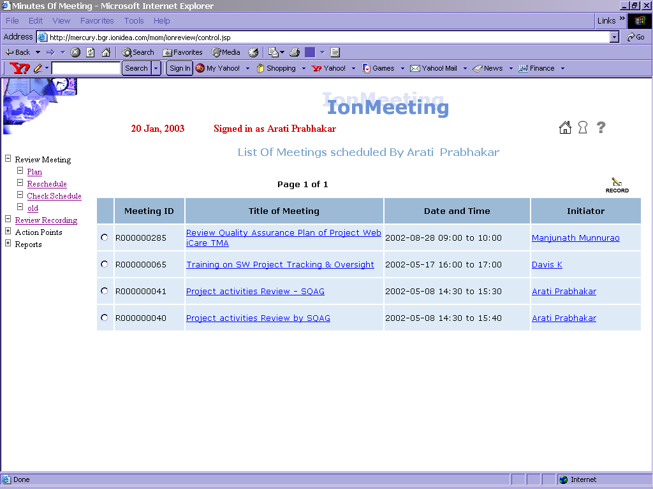.

Conclusion:
The benefits of effective Software Quality Assurance is inherent in the better discipline it has brought about in adhering to process and standards and created an air of increased awareness of the importance of Quality in satisfying and retaining customers. We firmly believe that future shall bring us quantitative basis for demonstrating the significant benefits of Quality Assurance like measurable trade mark Quality, reduced re-work which implies lower costs and also improved time-to-market.
References:
[1] “Guerrilla SQA & Metrics – Conquering the Land a bit at a time while leaving the developers Alone”. (stickyminds.com)
[2] From Software Quality Control to Quality Assurance – An MKS white paper.
[3] “Practices of High Maturity Organizations” – Mark C Paulk 1999 SEPG Conf, Atlanta.
[4] “The Capability Maturity Model – Guidelines for Improving the Software Process” Carnegie Melon University, SEI (Pearson Education Series)
[5] “IonExpress” – IonIdea Quality Management System, Ver 2.2 Dt Nov 29 2002
.

