Sanity Testing

Table of Contents
1 Business Competition 1
2 Sanity Testing 2
3 Importance of Sanity Testing 3
4 Bringing the disparity between Smoke Testing and Sanity Testing 4
5 Approach to Sanity Testing 5
6 Value of Sanity Testing 6
7 Limitations of Sanity Testing 7
8 Conclusion 8
Reference 8
About Author 8

Prepared by:
Lokesh Gulechha

Submitted for:
<<Text>>

Date:
September 2007

Business Competition


Increase in competition and leaps in technology have forced companies to adopt innovative approaches to have an application which is 100% error free. Having more features and functionality may not necessarily translate into success for a product or application—what ultimately counts is how stable the consumer finds these features. This can be achieved by applying different types of testing methods and one such type of testing is “Sanity Testing”.

Sanity Testing


Sanity testing means the test engineer will verify the major functionalities of the application to test whether the application is ready for testing or not.
In other words, it is a very brief run-through of the functionality of a computer program, system, calculation, or other analysis, to assure that the system or methodology works as expected, often prior to a more exhaustive round of testing.
In short, Sanity works on Rule of Thumb.

Rule of Thumb
A rule of thumb is a principle with broad application that is not intended to be strictly accurate or reliable for every situation. It is an easily learned and easily applied procedure for approximately calculating or recalling some value, or for making some determination.

Importance of Sanity Testing
With the evolution of test methodologies, sanity tests are useful for identifying problems related to different area of application. Some of these are:-
- Initial Environment Validation: The process of sanity testing begins with the execution of some online transactions, batch programs of various modules to see whether the software runs without any hindrance or abnormal termination. This practice can help identify most of the environment related problems.
For example, if a person has just set up a computer and a compiler, a quick sanity test can be performed to see if the compiler actually works: write a program that simply displays the words "hello world".
- Identify Missing Object: Sanity testing helps to identify the dependent missing objects.
- Application Stability Test: Sanity Testing is used to check whether a new version of application is stable and performing well. It normally includes a set of core tests of basic GUI functionality to demonstrate connectivity to the database, application servers, printers, etc.
For example, an application is crashing the system and destroying the database every ten minutes, which means that the testing cannot be carried on as the current state is not stable.
- Check for missing errors from previous build: Sanity testing is carried on to check a particular functionality which had errors in previous versions and were not able to proceed further and which is ready for testing in latest version.

Bringing the disparity between Smoke Testing and Sanity Testing
There are occasions where some testing communities often equated Sanity testing and Smoke testing. Below table draws the difference between the two:
Disparity between Smoke Testing and Sanity Testing
Smoke Testing | Sanity Testing
Is done to ensure high priority functionality of application works as required. |  | Is done to ensure system works as required.
Is scripted - either using a written set of tests or an automated test |  | Is unscripted.
Is designed to touch every part of the application in a cursory way.  It is shallow and wide. |  | Is used to determine a small section of the application is still working after a minor change.  It is narrow and deep.

Approach to Sanity Testing
When to perform Sanity Testing?
Sanity testing is performed at the beginning of STLC (Software Testing Life Cycle) often prior to a more exhaustive round of testing and it can be performed for all types of testing.
STLC flow without and with Sanity Testing:
STLC flow without Sanity Testing | STLC flow with Sanity Testing
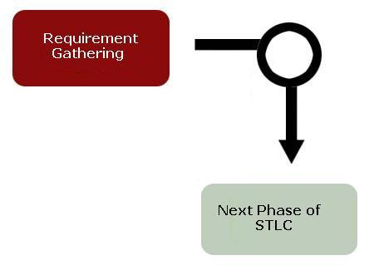 | 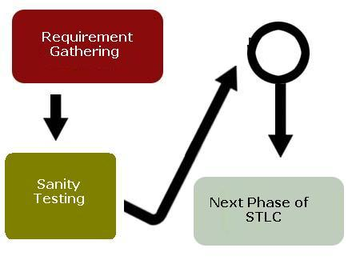
Flow of Sanity Testing
Exhibit 1: Flow of Sanity Testing

Is sufficient testing done?

Add a Test
Run a Test
Note result of Test
Is application stable?

Detail round of Testing
Request for New Build or add missing object
Yes
Yes
No
No

Value of Sanity Testing
One wise man said “One Good decision at Start can cover a lot“. Following is the Traditional cost of change curve for STLC. It shows the cost of fixing errors increases exponentially the later they are detected in the lifecycle.
Exhibit 2: Cost of change Curve
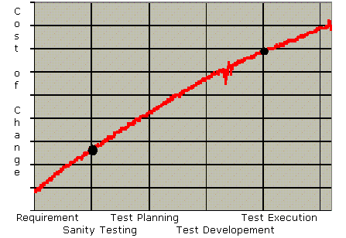

Limitations of Sanity Testing
There are some limitations to sanity testing: -
- Since it is an unscripted testing method, reproducibility could be a problem.
- It suffers for a small scope (time, number of machines and people tasked) compared to the real installed base and usage patterns.

Conclusion
Early detection prevents the loss of time and effort. Sanity Testing is performed to ensure application stability before proceeding to more exhaustive round of testing. It is performed whenever cursory testing is sufficient to prove the application is functioning according to specifications. Sanity testing results in lower cost for fixing issues related to Environmental instability, missing objects.
Reference
- Wikipedia – The Free Encyclopedia, http://en.wikipedia.org/wiki/Sanity_testing
About Author
A Capgemini India Test Engineer with over two years of proven test execution and test analysis experience using HP tools in Financial services sector.
To reach e-mail at lokeshkumar.gulechha@capgemini.com

Capgemini Financial Services
6400 Shafer Court
Rosemont, Illinois 60018
Phone (847) 384 6100, Fax: (847) 384 0500

